**GLENBROOK POINTS**

**Newsletter of Glenbrook & District Historical Society Inc.**

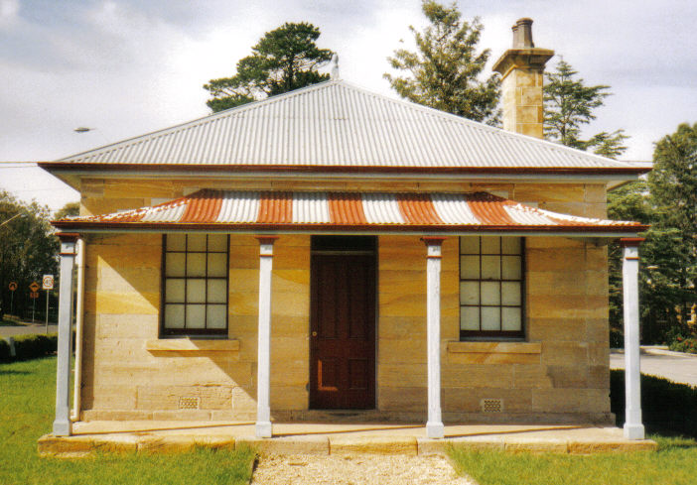 **POINTSMAN'S COTTAGE**

**AUG-SEPT '18**

**Postal address P.O. Box 38 Glenbrook NSW 2773**

**Contacts:** President Joan Peard 0414 605 482 or Secretary Neil McGlashan 4739 9864

**EDITOR** W.(Bill) Peard …. E-mail:- jpe13704@gmail.com

E-mail:- gdhs@gmail.com Facebook:- Glenbrook & District Historical Society Inc

**Meetings 3rd Wednesday monthly at 1.30 pm (except Dec-Jan) Glenbrook Guides Hall**

**cnr Hare & Moore Sts. Glenbrook**

"HISTORY WALKS" PROGRAMME for 2018.

**All on Saturdays: Walks led by Doug. Knowles & Team.**

**Sept. 1st: 9.00am “Eastern Zig Zag Railway 1867”** and the first improvement: The Lapstone Hill Tunnel route. 1892

**Sept. 29th: 9.00am “Glenbrook Heritage Walk.”** Historic sites, houses and West Portal of Lapstone Hill Tunnel--1892. **( Last Walk for the year.)**

***BOOKINGS are ESSENTIAL:*** *Phone Doug on* ***4751 3275****. Please allow the phone to ring longer than usual for details re meeting place, time and grade of walk. Good walking shoes are essential. Please bring a hat and drinking water. (No dogs please.)* ***BAD WEATHER ON THE DAY:*** *Excessive wind or rain could cause cancellation due to hazardous conditions.* ***Adults: $10 (****Except for Special Walk.)* ***Accompanied Children under 16yrs. Free***

***ERROR****: June/July* *article “St.Finbars Church 1912” by Patricia Murnane..”Blaxland, Lawson & Wentwoth* ***camped nearby****” should read* ***“PASSED NEARBY****”. Refer to Newsletter Feb/March 2015 article BRIEF HISTORY GLENBROOK.*

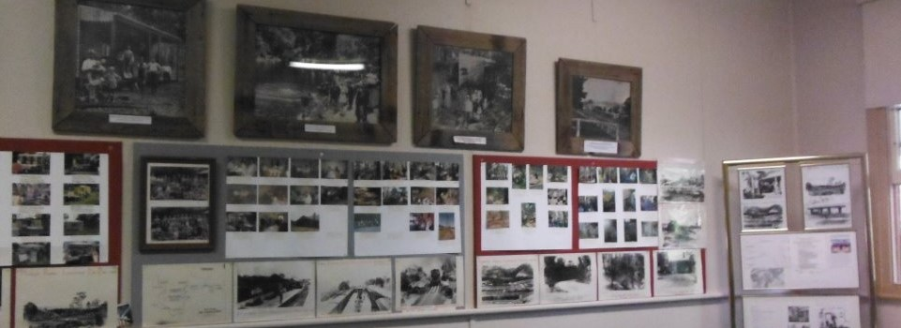

***G.& D.H.Society***

***MUSEUM***

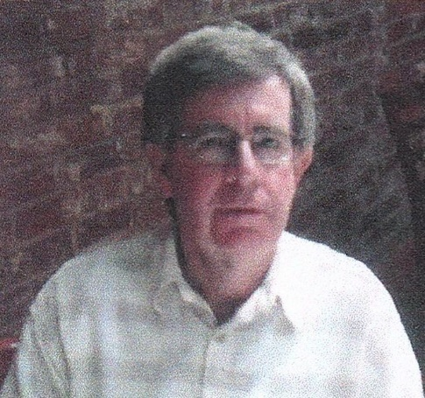***ST. ANDREW’S UNITING CHURCH GLENBROOK***

**BRIEF HISTORY (by Peter Berry)**

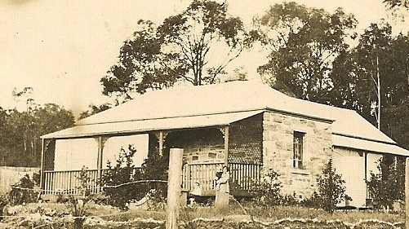 The origins of Glenbrook Uniting Church church go back as far as the early 1880s when, through research carried out by the late Ken Pickering, the Nepean Times in 1883 reported that the Presbyterian minister from Penrith/St.Marys, the Rev Clausen used to come up to the tiny village of Glenbrook once a month on Friday evenings in his horse and buggy to visit a few Presbyterian families in the village.

A little Presbyterian congregation formed over the following years and first formally met as such during an evening service in the village in 1927 with about a dozen people present. The services were held in the King Street homes of Mrs Gibb and Mr W.H.& Mrs Williams. Both homes still exist today.

***Mr W.H.& Mrs Williams home "Wyuna" King******St***

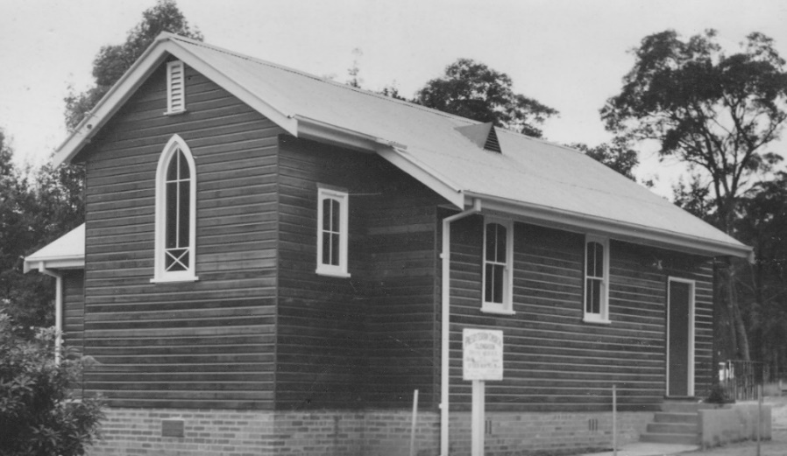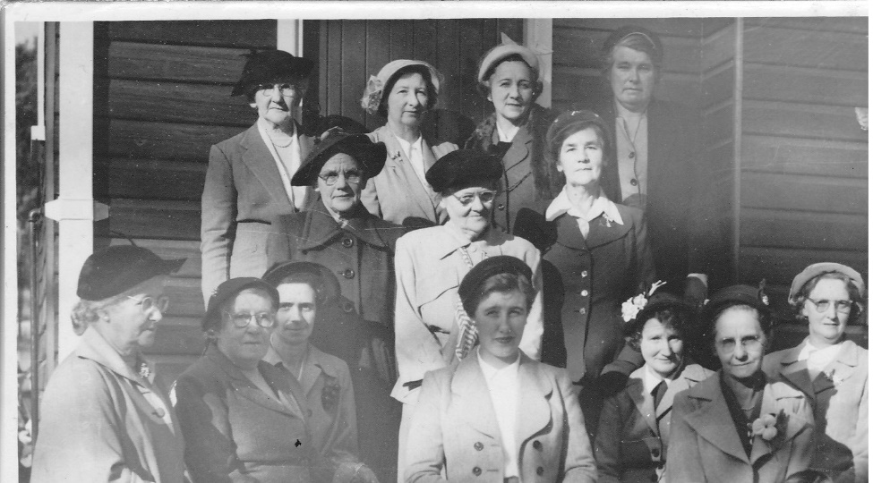 Other people there at the beginning were George and Jessie Bunyan who were pioneers of Glenbrook and whose daughter, Joan Peard, remains connected to the church to today. Services were held in private homes for some years but later the Glenbrook School of Arts was used for weekly worship. The Glenbrook congregation was then part of the Springwood Presbyterian parish. In 1951 a Women’s Guild was formed and set about raising money to buy a block of land. Key women involved were as photograph► left-right Top row. 1.Mrs Burfield 2.Mrs Bunyan 4.Mrs Pickering. Middle row 1.Mrs Lovett Front row 1.Mrs.Williams 3.MissV.Fisher 5. Mrs.Clague 6. Mrs.Cartwright. The ladies raised the necessary funds to purchase the block of land on the corner of Lucasville Road andGreen Street and a church was subsequently built by voluntary labour at a cost of £750 ($1500). Names of all the volunteers were buried in a bottle under the church which, as far as is known, remains there today. The church was formally opened on a cold Saturday afternoon on 12th June 1954. Margaret Elizabeth Williams was the first child baptised when the congregation met in the King Street home of Mrs Gibb. The same Margaret Elizabeth Williams was the first person married in the newly built Lucasville Road church.

***St.Andrews 1954***

***St.Andrews Womens Guild 1954***

The church was later added to and improved several times and a hall built with major extensions being carried out in 1979. For a long while Glenbrook and Blaxland was a joint Presbyterian parish but when the Uniting Church came into being in 1977, Blaxland remained Presbyterian and Glenbrook became part of the new Uniting Church. Glenbrook was the only Presbyterian Church between Penrith and Lithgow to become part of the Uniting Church. Since the beginning of the Uniting Church, there have been 6 permanent ministers Rev. Michiel Groenewegen, Rev. Keith Esterbrook, Rev. Neil Smith, Rev. Elizabeth Orr, Rev. Susan Phalen and from April 2018 Rev Ellie Elia.

The 14 pews were made by Alec Dunn (Builder) costing £210, and donations by Mr & Mrs Pickering (Organ), Mr & Mrs Clague (Hymnal board), Mr & Mrs G. Bunyan (Communion Table in memory of daughter Jessie), Mr Alec Dunn (Pulpit in memory of his parents ( Mr & Mrs J.C.Dunn), Mr & Mrs W.H.Williams (Baptismal Font in memory of son Eric), P.W.A. ( Carpet and Runners)

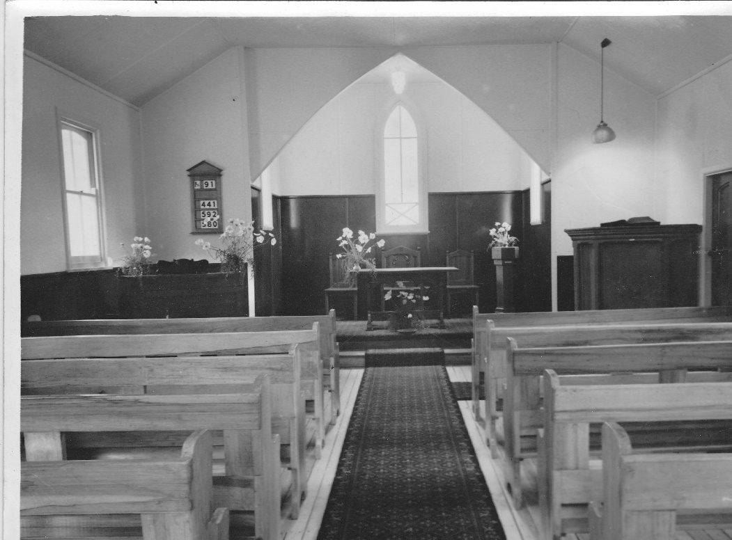

***St.Andrews Church Glenbrook 1954***

**DID YOU KNOW???? …. SO*M*E T*R*IVI*A***

When the 1st Public School opened in Glenbrook 1892, the children had to have their lesson in the park… The furniture had not arrived.

1901 census in Glenbrook there were 122 inhabitants in 26 dwellings & 17 weekenders. In Wascoe (now Blaxland) 33, 6 & 1 respectively. (Editor: I would assume that weekenders had no inhabitants in the count}

In 1882 there were 2 trains daily to Glenbrook, with extra 2 services on Saturday but none on Sunday. The fare was 2 pence/mile 1st class & 1 pence/mile 2nd class.

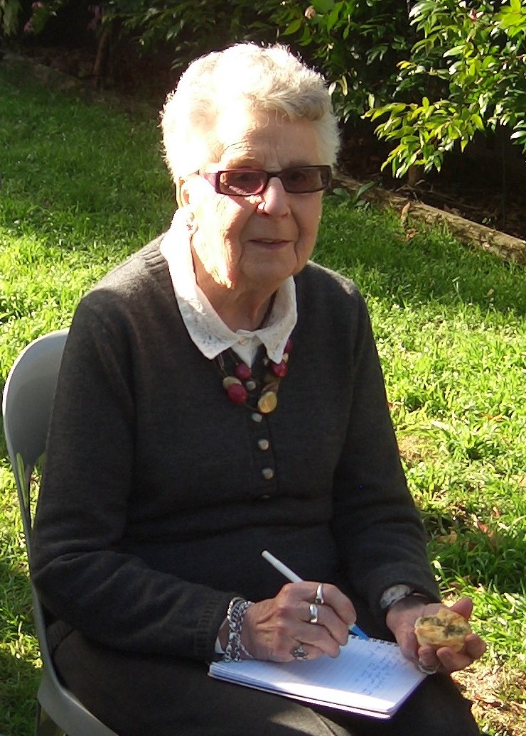**PAM’S PAGE**

**RED HAND CAVE**

For many thousands of years the Durrak people lived in and roamed in these Blue Mountains and proof of history remains in the “Red hand cave”, which is in the National Park in Glenbrook. An article appeared in the Nepean Times in 1933 with the following story, *“Four miles South West of Glenbrook is the site of the Red Hand Cave. The few authorities on Aboriginal Lore, who have seen the cave, say it is the most striking example of it’s kind in Australia”.* Few people know of it’s existence and fewer could find their way there.

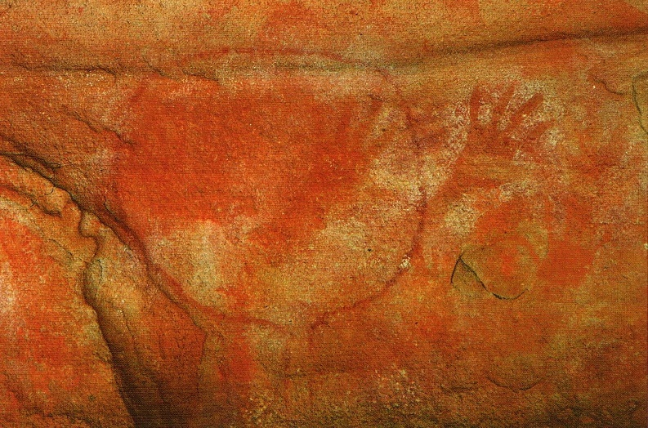 The cave was found by accident in August 1913 and an inscription on the cave wall, found and photographed by amateur archaeologist Clifton Towle 1933, read *“Jim Dunn 10 August 1913”,* James (Jim) Colquhoun Dunn, a Glenbrook builder, with George Ernest Bunyan, an Emu Plains butcher & bushman, together with a party of local railway workers, in August 1913 were searching for a young (21yrs) Glenbrook girl, Ruby Hunter. She was a cousin of Jim Dunn. Ruby left her Glenbrook home together with her two dogs, to collect flowers in the bush and became hopelessly lost. Ruby was found safe, near Glenbrook Creek and closer to Blaxland, It is believed that during this search Jim Dunn made the inscription on the wall.

George E.Bunyan guided Mr W.Thorpe Ethnologist & Mr C Clutton Photographer from the Sydney Museum to the site on 17th March 1924. They were met by Messrs T.Cornell, J.Dunn, G.K.Bunyan, A.Gates (Nepean Times) and all were amazed at the hand prints, The method of hand painting was to grind into powder a piece of red sandstone and mix this with water. Taking a mouthful, the Aboriginal blew in a fine stream all around the outline of their hands. Another of the markings is a rough circle with the hand prints inside the circle and is thought to be the equivalant of a visitors book where travellers from other areas would leave their mark.

*Red Hand Cave*

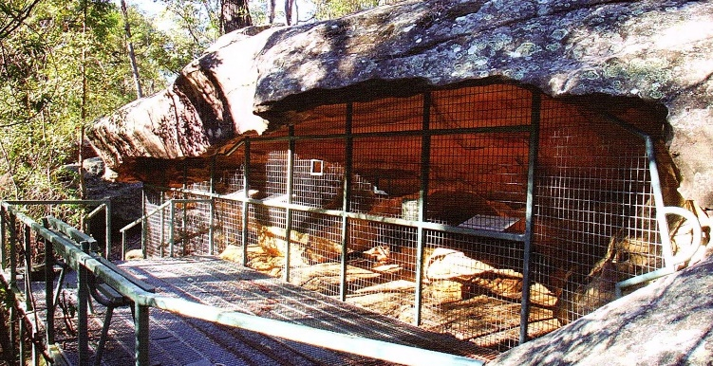 Unfortunately as the popularity of the National Park grew, more visitors came to visit the cave and it was slowly becoming defaced. To stop this awful practice continuing, there is now a grill covering the front of the cave to protect this very interesting part of Darruk history for generations to come.

***Viewing Platform Red Hand Cave***

**KELGOOLA HOUSE (now Ilford)1884-1984**

**8 Wascoe St. Glenbrook**

A gothic styled picket fence and gable roofed lych-gate form a most inviting entrance to the whitewashed stone cottage nestled amongst a myriad of flowering shrubs and maturing pines. Today known as “Ilford House”, this semi-secluded cottage has observed the comings and goings of many a distant traveller since the mid 1880’s, but has remained fairly inconspicuous itself. Little was known about the house when purchased by it’s owners in 1984, being described by them then as a house of mystery.

Some of the mystery has been solved since that time and is now known that the house was built in 1884 by Scottish stonemason, Donald Ross, making it one of the oldest in Glenbrook. Situated near the traffic lights on Great Western Highway, it would have watched the fascinating sight of steam trains choofing past its front door until the early part of 20th century when the railway line was were the highway is now today. Ross bought the undeveloped land from William Deane, a Sydney solicitor, who also owned Pilgram Inn. Deane purchased a block from David Brown who had been granted a parcel of land. On todays map this would be from Lennox St. to Mann St. & Wascoe St. to railway

line.

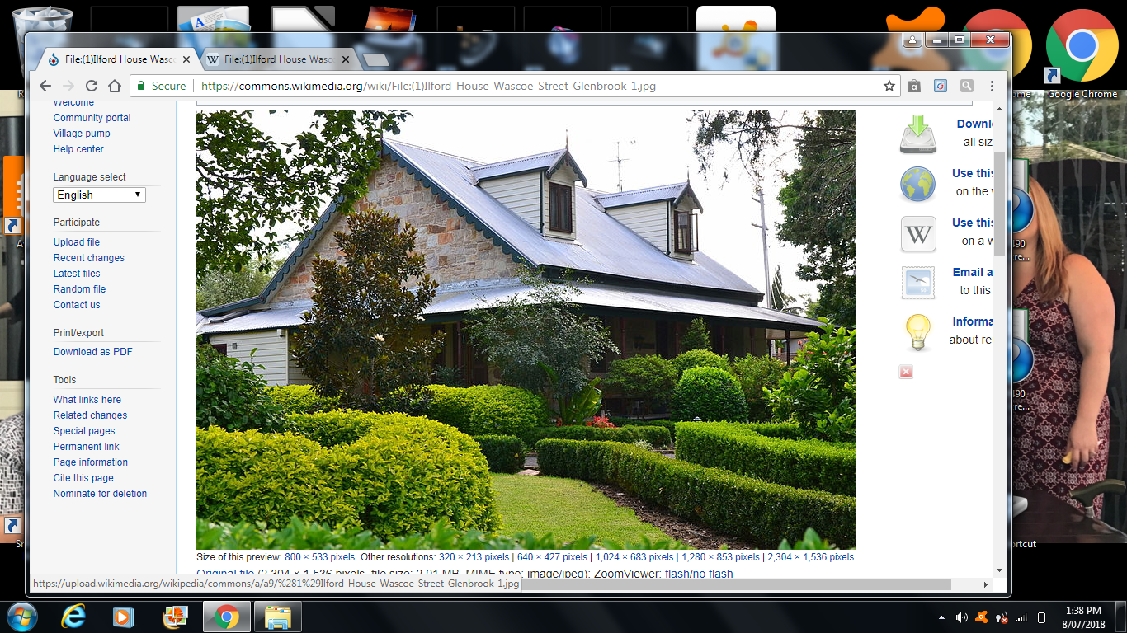 It appears that Donald Ross was no stranger to accomplishing feats of considerable magnitude. He was almost 60 years old when he quarried all the sandstone from the property to build this fine residence in order to accommodate his rather unique family of 6 daughters and himself. Sadly his wife Mary was unable to share in the joy of living in this house, as she had died some years earlier, age 40yrs. and buried at Emu Plains. Ross not only cut all the stone for the house, with assistance from John C. Dunn of Glenbrook, whom he trained, but also sank a 5ft. square by 30ft. deep well, which contains about 10 to 12 ft. of water even in the driest of times. Financial difficulties forced foreclosure of his mortgage in 1886. He and his daughters moved to Sydney where he soon died.

***"Ilford House"***

It is also known that from 1901 to 1909 the house belonged to Samuel Hewitt of Springwood, the first of two publicans to own it. He is reputed to have built the large multi-roomed weatherboard cottage adjacent to the main stone house for the accommodation of overland travellers and the teams of railway construction workers that were present in the area at the time. Hewitt also built a 4 stall stable and a coach house for the convenience of his guests.

Samuel sold the property to Mrs Adelaide Kelly, 1909, wife of Peter Kelly from Wisemans Ferry, She was granted a boarding house licence and ran it as such until 1934. A “Full House” sign would have been displayed often, particularly for railwaymen during 1911-1913, and for the local Policeman, Constable T.M. Mooney. There was also a Police Holding building built in the yard. The Kellys played host to hard working, hard drinking men. However it is most likely they were kept in line by the local Constable. The guests at the time of both Hewitt and Kelly would have enjoyed home cooked meals whilst seated comfortably in splendid surroundings in the main house. The Police building was later burnt down.

A member of State Parliament, Robert O’Halloran and his wife Irene, bought the property in 1934, ending the property’s days as a boarding house. The house became their private home and they converted the boarding house to a flat. c1945 their married daughter, Irene and husband Stuart Williams, occupied the property until the family moved in 1955. The property had many owners/tennents until Steven & Florence Malmberg in 1984 purchased the property. They changed the name to “Ilford”. More on that subject…TO BE CONTINUED

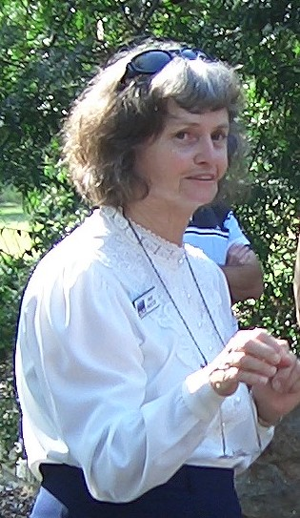**Visit to NSW State Archives Kingswood**

***Pam Pascoe Activities Officer***

******Our next trip will be to the NSW State Archives Kingswood. This will take place at **10 am Tuesday 25 September 2018**. A car pool will be our way of transport, meeting at the Girl Guides Hall. Following our tour, lunch will be at either the Penrith Hotel Bistro or Glenmore Golf Club Bistro. Attendees will need to keep in touch with me if they will not be attending our general meetings on the 15th August and 19th September. At these meetings updates will be given. This current Newsletter will be the last one to advertise the event. Our visit to the Archives is generally what takes place behind the scenes of which there are many treasures to be found. State Archives have documents etc. back to 1788. They also have many photos; family historical records; First Fleeters; NSW Colonial Secretary’s correspondence, 19th Century (reflects events of NSW and the lives of individuals at the time)There will be tips on research and how to go about it; Rare Documents; Family history and House histories

***FROM THE SECRETARY’S DESK***

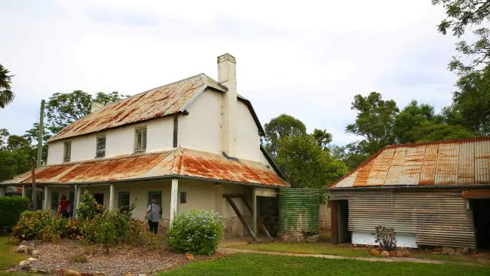

***Hadley Park Castlereagh***

**1.**  **Jacqueline Flower**, the last living descendant to occupy Hadley Parkwas introduced by Denis. Jacqui gave an excellent and informative talk onher life there and her relatives. The main house was built in 1812 and the separate building which was used as their kitchen was the original house built in 1806. Kevin thanked her at the end and she was presented with some flowers for coming and addressing our meeting.

**2. Blinky Bill Bus Shelter:** Discuss leaving it where it is or moving it to the highway so it becomes a bus shelter again. Council spent thousands of dollars replacing it. Tourist buses stop there for a toilet break, it is near the children's playground, people take photos of it there and it is safer there from being hit or from graffiti than if it was on the highway. Sure Council would not want to spend more money moving it.

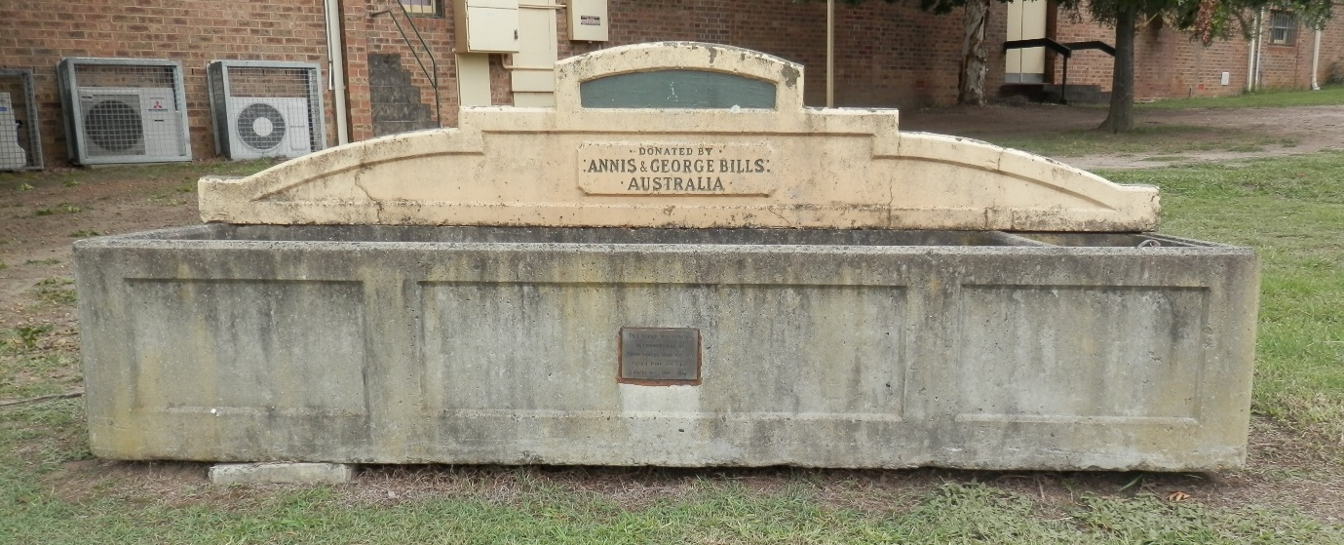**3. Bills Horse Trough** We decided a couple of years ago to have it in a more prominent position near the Visitors Information Centre when it is completed. It is wasted where it is. The Management Committee said to put this position to council which Neil will do.

***Bills Horse Trough***

**4. Pioneers Wall relocation:** Reply sent to Council estimating 20 plaques into the future. Hamment family, the oldest in Glenbrook does not have a plaque so that is a new one to go on.

**5.** **RAAF 1941 Plaque Clifton Avenue:** Registered it with War Memorials in NSW. It was never officially registered, sent them the history and the video. Jane at the department was a great help. Now registered we can apply for funds once we decide what we want to do. Perhaps a low post and chain fence around it with gravel to make it more noticeable. It is on Council land. Damien Madigan, editor of the Gazette is doing a story on it & to get recollections from our members who were there in 1941

**6.** **Meeting with Museum Advisor:** We had the meeting with Gay Hendriksen, who is employed by Council and Museum Collections Association, who advised us on things we can do and will provide further information to us in due course.

**7.** **Scenic Eastern Escarpment Master Plan:** Following up on the Gazette article where the Blue Mountains Conservation Society (BMCS) did not support a new bike trail linking reserves and extending bike riding options. The National Trust Heritage Advisory Committee are worried about the over use of parks and its effect on vegetation, erosion and wildlife.

**8.** History Walks are continuing in 2019.

**9.** We received a letter from Bev Hughes (nee Carey) thanking Doug and Joan, complimenting us on the Museum and for joining them to farewell and scatter Ken Carey’s ashes off The Bluff.

**GLENBROOK & DISTRICT HISTORICAL SOCIETY Inc.**

**OFFICE BEARERS 2017-2018**

**President: Joan Peard 0414605482 Secretary: Neil McGlashen Vice- Presidents 1st. Kevin Frappell 2nd Doug Knowles**

**Treasurer: Anton VonSchulenberg Chief Historian: Tim Miers**

**Committee: Pam Thompson Denis Bainbridge Ian Dingwall**

**Glenbrook & D.H. Society Museum is situated within Old Glenbrook Infants School, Ross St. entrance via Park or Ross Sts Museum is open every 1st & 3rd Saturdays 9 am to 1 pm. Entrance FREE**