GLENBROOK POINTS
Newsletter of Glenbrook & District Historical Society Inc.
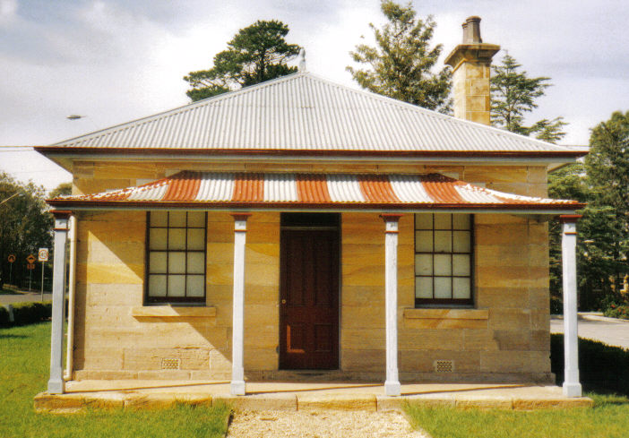
POINTSMAN'S COTTAGE
JUNE-JULY '18
Postal address P.O. Box 38 Glenbrook NSW 2773
Contacts: President Joan Peard 0414 605 482 or Secretary Neil McGlashan 4739 9864
EDITOR W.(Bill) Peard …. E-mail:- jpe13704@gmail.com
E-mail:- gdhs@gmail.com Facebook:- Glenbrook & District Historical Society Inc
Meetings 3rd Wednesday monthly at 1.30 pm (except Dec-Jan) Glenbrook Guides Hall
cnr Hare & Moore Sts. Glenbrook

"HISTORY WALKS" PROGRAMME for 2018.
All on Saturdays: Walks led by Doug. Knowles & Team.
June 9th: 1.30pm “Lapstone Construction Railway.” 1910--1913 and east portal of Lapstone Hill Tunnel 1892.
23rd: 1.30pm “Duck Hole--Glenbrook Creek.” Old Roadway construction and pump site for railway water supply to old Glenbrook Station.
July 14th: 1.30pm “Dunn’s Steam Sawmill Site” and earth dam. Brookside Creek, Lennox Bridge and the old stone quarry.
Aug. 4th: 9.00am “Bull’s Creek.” Railway relics:- Stone dam and steam pump relics.
Sept. 1st: 9.00am “Eastern Zig Zag Railway 1867” and the first improvement: The Lapstone Hill Tunnel route. 1892
Sept. 29th: 9.00am “Glenbrook Heritage Walk.” Historic sites, houses and West Portal of Lapstone Hill Tunnel--1892. ( Last Walk for the year.)
BOOKINGS are ESSENTIAL: Phone Doug on 4751 3275. Please allow the phone to ring longer than usual for details re meeting place, time and grade of walk. Good walking shoes are essential. Please bring a hat and drinking water. (No dogs please.) BAD WEATHER ON THE DAY: Excessive wind or rain could cause cancellation due to hazardous conditions. Adults: $10 (Except for Special Walk.) Accompanied Children under 16yrs. Free

ERROR:-Apr-May ‘18 issue “Baxland’s Lost History” Davina Curnow incorrectly reported “Public School built …..” should read 1925 & “fires also destroyed historic…” should read historic Church & Rectory.
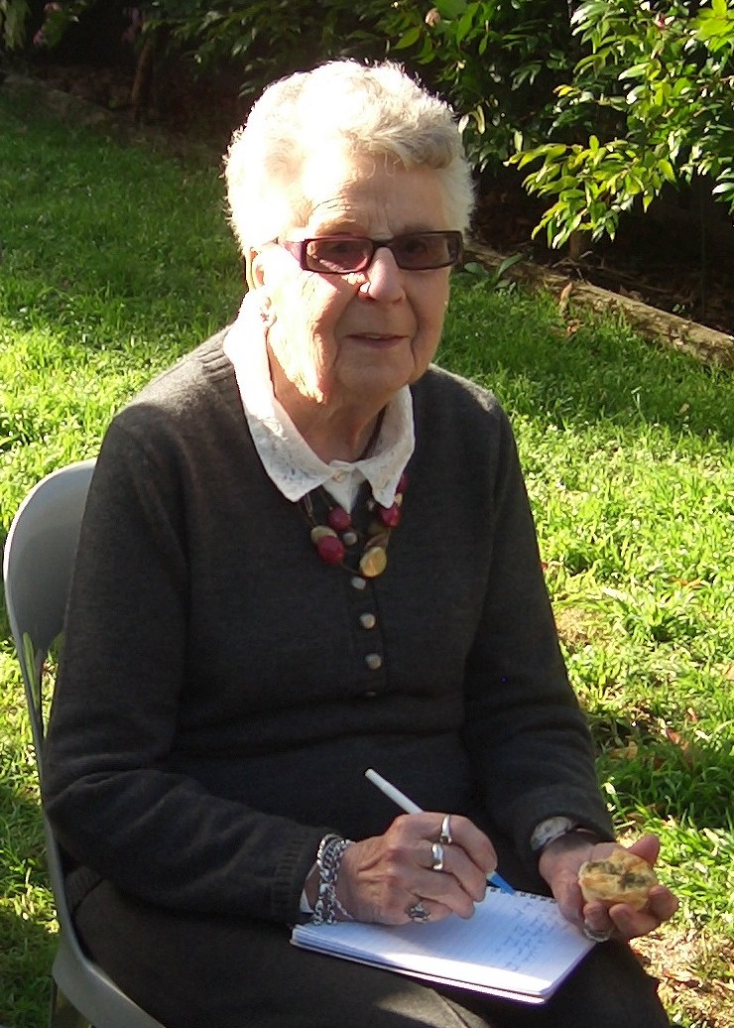
PAM’S PAGE
R.A.A.F. PLANE CRASH 1941
At about 4.50 p.m.on 28th January 1941 a R.A.A.F. Avro Anson aircraft No A4-5 crashed on the corner of Clifton Ave and Lucasville Rd. It was flying from Parkes to Sydney with a crew of 3 and a medical officer with Pilot Officer, Bailey Sawyer, being flown to Sydney suffering from a severe ear problem, and was too ill to travel by train.
My sister, Dianna, and I and some friends were playing in the backyard at home, Southern end of Clifton Ave, we heard the aircraft coming from a South-West direction, over the Nartional Park. We heard the noise first and then could see it getting lower and lower with pieces falling from it. The plane then flew over our heads and crashed with a huge plume of black smoke and flames.The plane had crashed at the corner of Clifton Ave and Lucasville Rd, missing the only three houses that were in Clifton Rd at that time.
There were no survivers, wreckage was thown everywhere, one engine had fallen on the footpath at the corner of Clifton Ave., and other parts and pieces, including bodies, were all over the place. Then, as now, police had to come from Penrith or Springwood, and the R.A.A.F. from Richmond, so it was some time before any officials arrived. Not so the people from the village, they came from everywhere in no time at all. My mother shut the gate and said that this is no place for children to be at, so although we were the closest to the crash site, we were the only ones not to get near it.
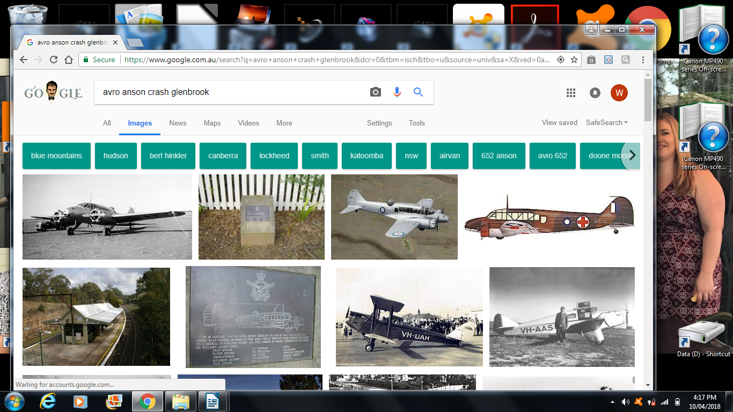 R.A.A.F. Avro Anson
In hindsite I suppose she was right, it was a terrible thing to witness and for years afterwards we wouldn’t walk to school that way, after rain, because of the dreadful smell. My father was driving home from work and was was stopped by the Service Police in Lucassville Rd, he detoured around to Explorers Rd but was stopped at Avoca St. same problem . However all was well when he explained where he lived.
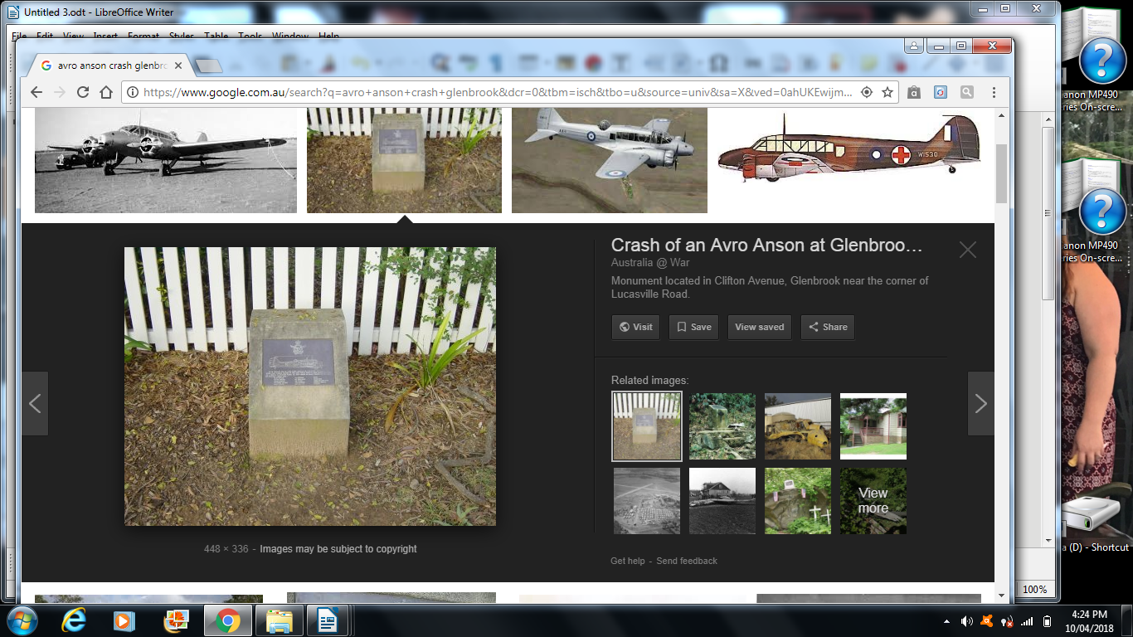
Clifton Ave. Brass Plaque
On 30th March 1994, the R.A.A.F. erected and dedicated a brass plaque on the Clifton Ave crash site to the memory of the five R.A.A.F. personel who died in the crash.
EDITOR:- R.A.A.F. Inspector of Aircraft Accidents reports on 4th March 1941, “A4-5 was heard at first flying above the cloud layer. It was then observed emerging from or through the clouds at a fairly steep angle and fast speed with the engines running quite regularly. Shortly afterwards the port wing was seen to shatter about the middle”. The Inspector found the cause of the accident to be the failure of the port wing which shattered about the middle shortly after the aircraft was brought down through the clouds. It was suggested (1) that the pilot may have descended through the cloud at an excessive speed to take advantage of a gap or for some reason connected with the patient (2) to some weakness in the wing structure. Names of deceased airmen :-Pilot John Newman, Navigator Henry Skillman, Wireless operator Charles Tysoe, Medical officer James Rainbow, Patient Bailey Sawyer. Source abridged version of “Dedication of Memorial at Glenbrook 24th March 1994”. Original documents may be read at G.&D.H.Society’s museum.

Glenbrook Railway deviation works and St Finbar’s Catholic Parish
Some notes by Patricia Murnane
Railway workers and St Finbar’s Community
St Finbar’s little wooden church in Levy Street, Glenbrook was built and opened in 1912, ninety-nine years after explorers, Blaxland, Wentworth and Lawson, passed nearby which is now the SE corner of Glenbrook Oval. It was a part of Penrith Catholic parish. From 1911-13 an influx of many workers and their families came for the railway deviation works.
The spiritual needs of the many Irish workers employed for the railway, prompted the building of the Catholic Church in Glenbrook, with land donated by Mr Harold Norrie, one-time Secretary to the Sydney Harbour Trust and the drive of Fr Thomas Barlow, Penrith Parish Priest.
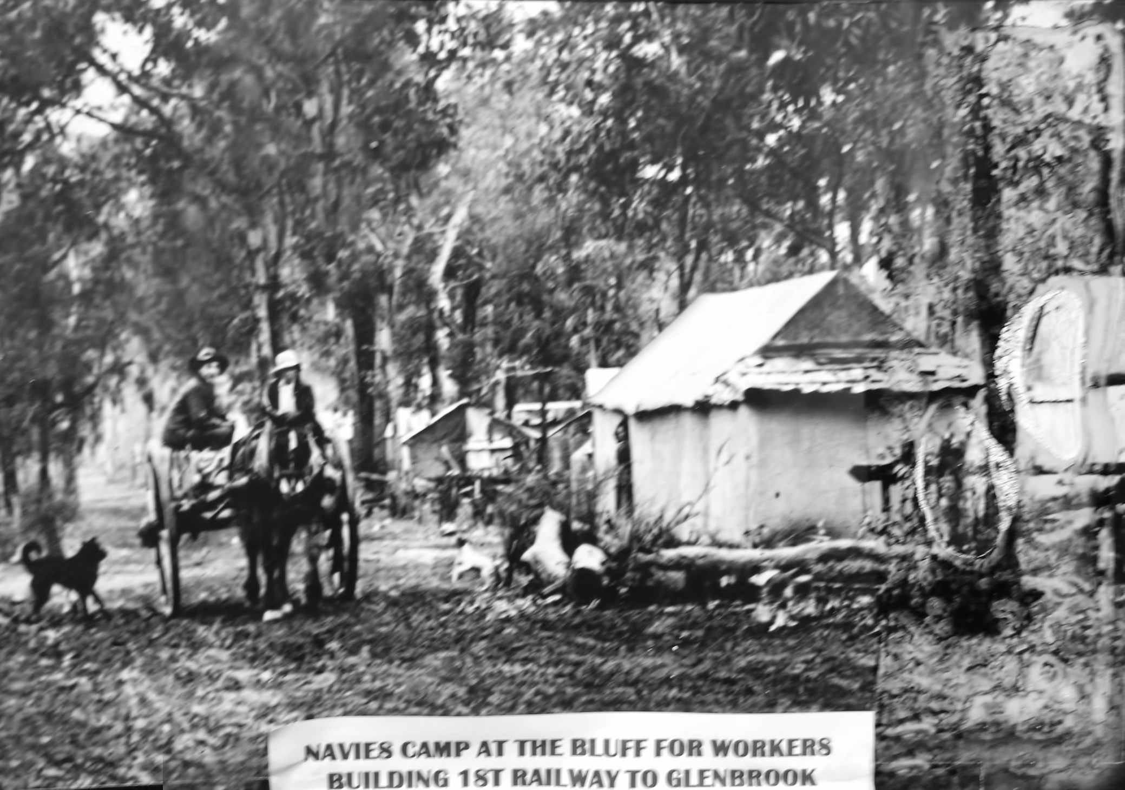
Emu Rd Main Camp Glenbrook
In 1912 there were 2 railway workers’ camps in Glenbrook, the Emu Rd Main Camp and one adjacent the site of the construction new Glenbrook station, while there was another camp at Blaxland.
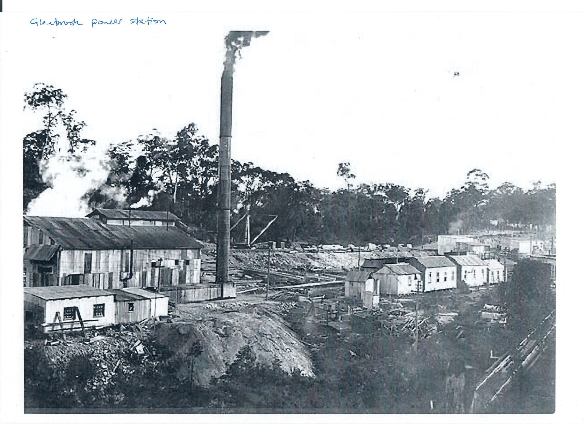
Glenbrook deviation Power House c1912
Nepean Times 22 June 1912,‘The Railway CampsOn Monday our representative paid visit to the Main Railway Camp near Glenbrook, where he had the pleasure of interviews with Messrs Williams, Bratby, Lyne, and numbers of other gentlemen. Mr Butcher, the courteous engineer was also seen. Everybody is busy on the encampments, and the men appear happy and contented. A huge travelling gantry crane was seen at work at the Blaxland Camp, the engineer (Mr Butcher) supervising operations. We also saw an immense hole cut out by blasting operations. The railway camps have transformed Glenbrook station from an insignificant station to a busy centre, there being about 1800 men employed, which including wives and families, means about 3000 people, and brings prosperity to the district. We are glad to say, however, that the courteous stationmaster (Mr Hatherly) finds time to give any information required by passengers and pressman. Messrs Casey, Williams and Bratby, of the Main Camp, are live, energetic men, heart and soul in everything for the good of the district; while Mr Patrick Lyne, of the Blaxland Camp, is a man full of grit and go, and everything he takes in hand must succeed.’
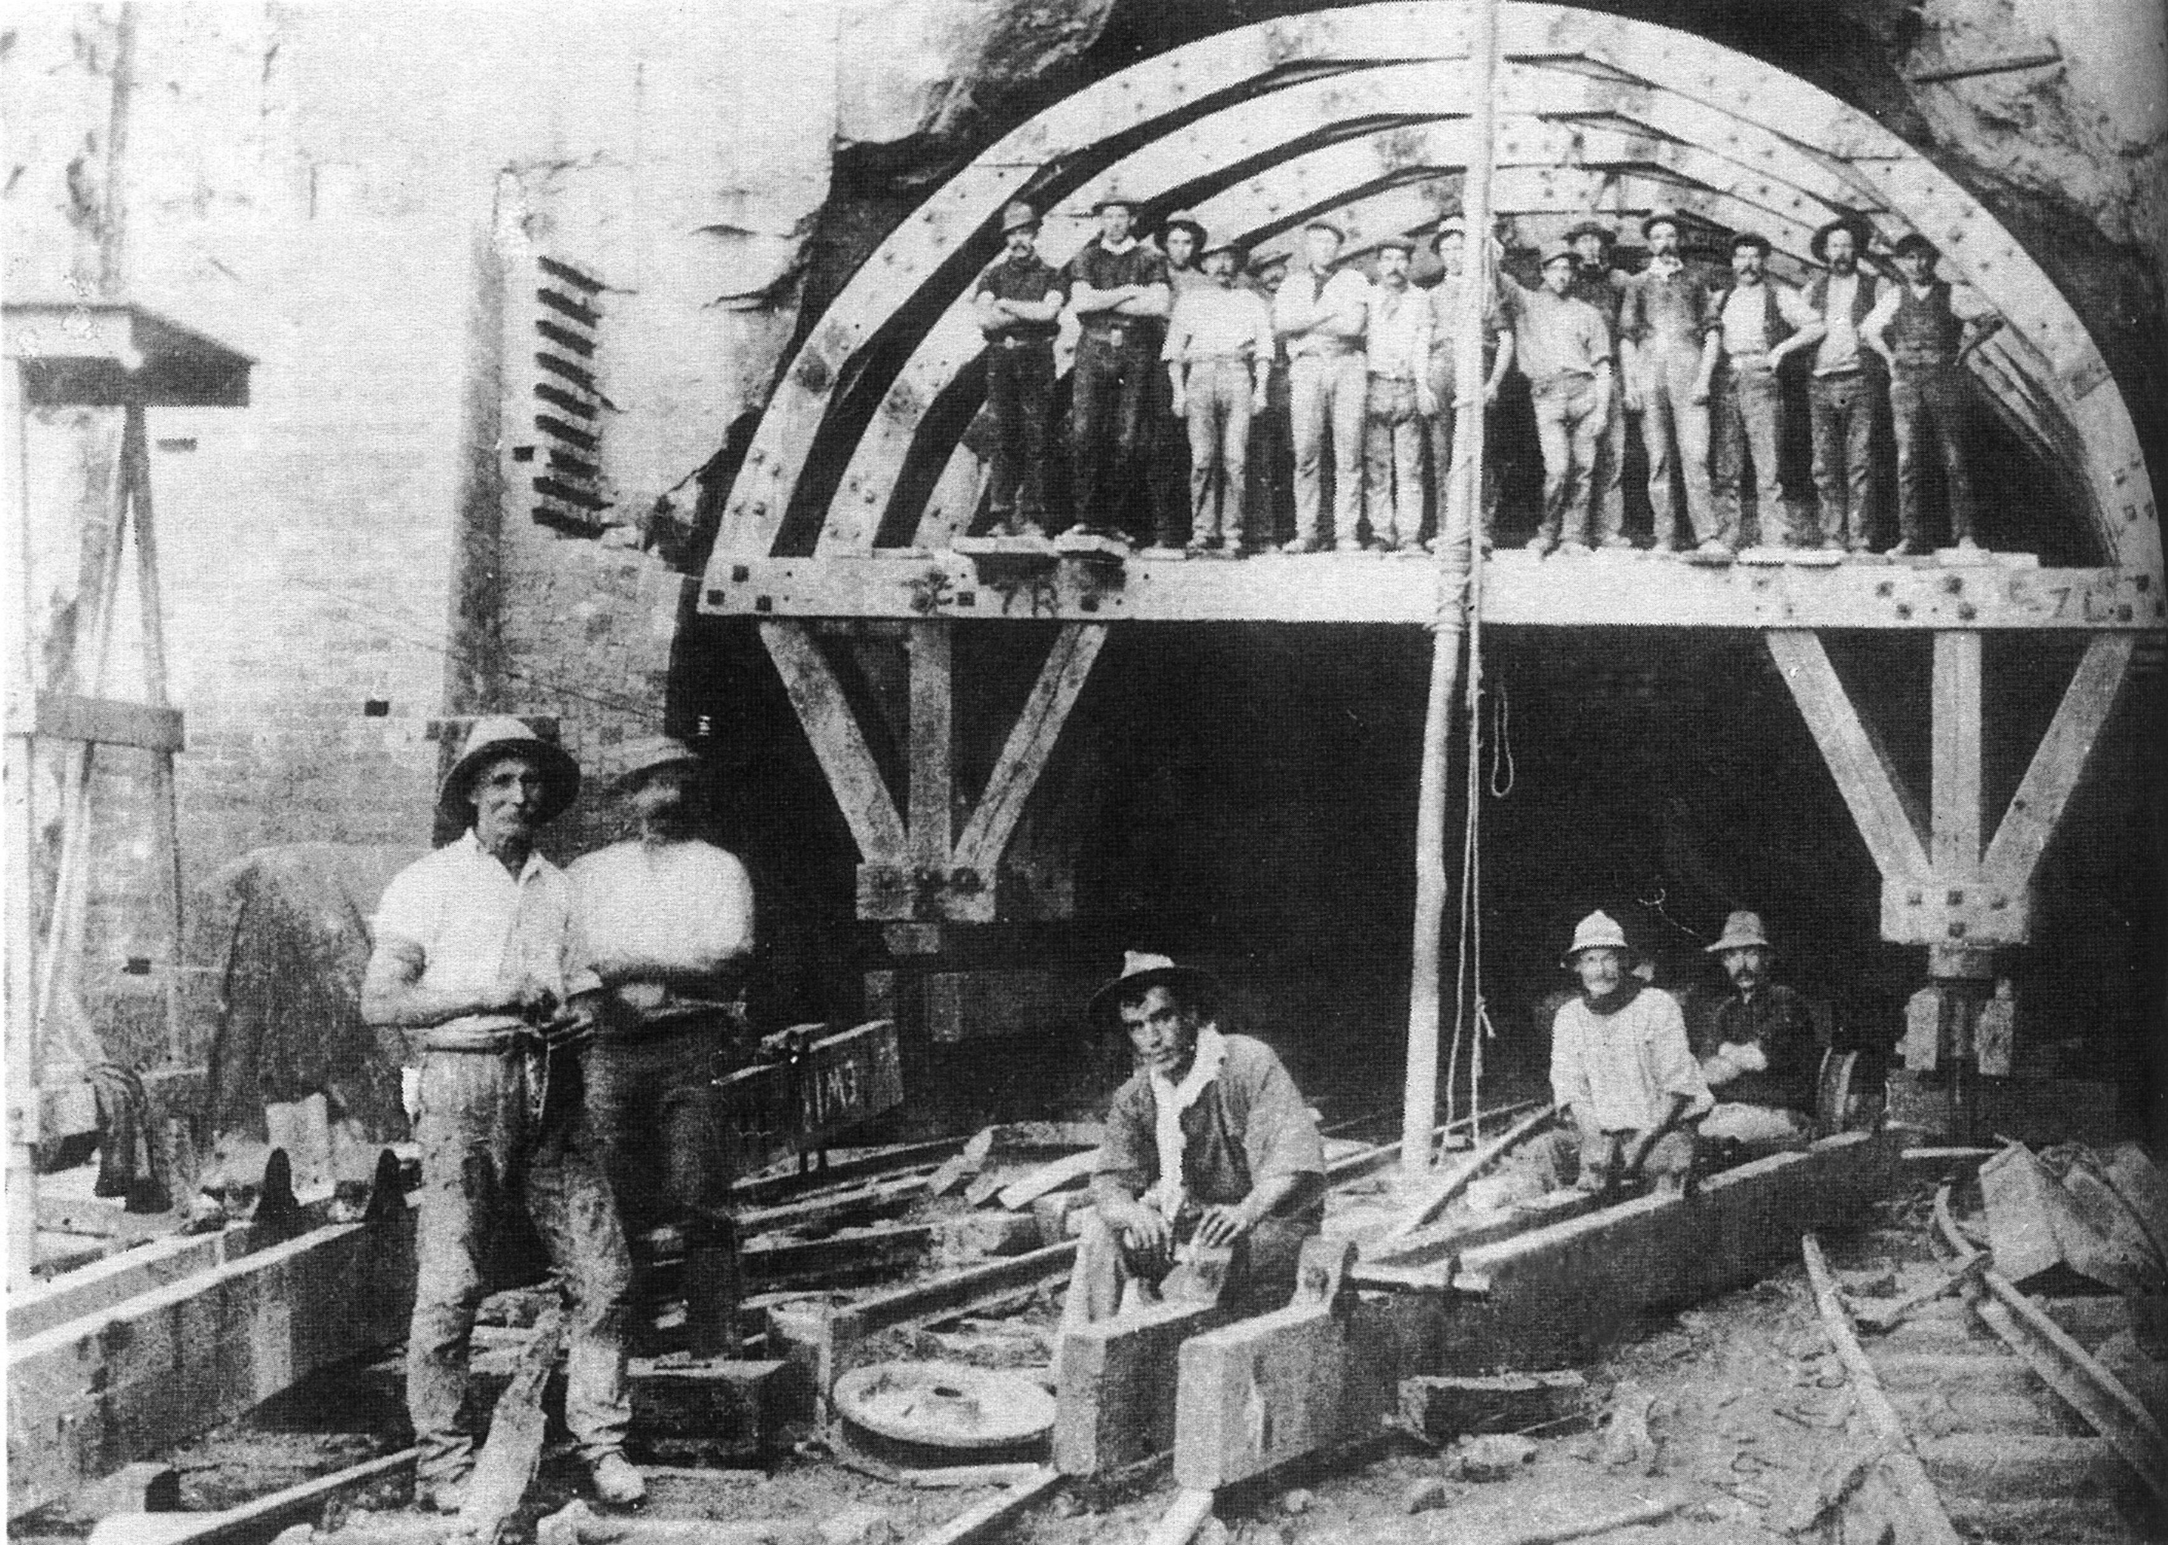
Glenbrook Tunnel Deviation 1911
Railway workers and St Finbar’s Community
A Catholic Mission was conducted by Father Gilmartin, a Franciscan priest on Sunday 10th February 1912 in the newly built St Finbar’s Church. The Nepean Times (Saturday 17.02.1912) reported that a large crowd attended the 10am Mass. The topic of the sermon was ‘Death’! The Mission continued over that week and included some sessions in the Union Hall at the railway navvies camp adjacent to what is now Emu Road. Unfortunately, a number of workers died during the construction so the sermon may have been somewhat prophetic.
The Nepean Times (Saturday 21.09.1912) page 4:
‘The Glenbrook Branch of the Railway Worker’s and General Labourers’ Association desire to thank Des Higgins and Pridham, the Matron and staff of the Nepean Cottage Hospital, for their kind attention to their late comrade, Arthur Jaynes.’

GLENBROOK & DISTRICT HISTORICAL SOCIETY Inc.
President Joan Peard 0414605482
Vice- Presidents Kevin Frappell Doug Knowles
Secretary Neil McGlashan Chief Historian Tim Miers
Committee Pam Thompson Denis Bainbridge Ian Dingwall
Treasurer Anton Von Schulenberg
Glenbrook & D.H. Society Museum is situated within Old Glenbrook Infants school, Ross St. Entrance via Park or Ross Sts
Museum is open 1st and 3rd Saturdays 9 am to 1 pm.
Entrance FREE


From the Secretary’s Desk

