**GLENBROOK POINTS**

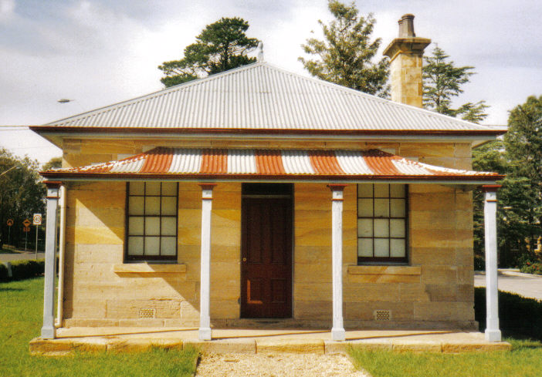**Newsletter of Glenbrook & District Historical Society Inc.**

**OCT-NOV '18**

**Postal address P.O. Box 38 Glenbrook NSW 2773**

**Contacts:** President: Denis Bainbridge Secretary: Neil McGlashan 4739 9864

**EDITOR** W.(Bill) Peard …. E-mail:- jpe13704@gmail.com

E-mail:- gdhs@gmail.com Facebook:- Glenbrook & District Historical Society Inc

**Meetings 3rd Wednesday monthly at 1.30 pm (except Dec-Jan) Glenbrook Guides Hall**

**cnr Hare & Moore Sts. Glenbrook**

"HISTORY WALKS" PROGRAMME for 2019.

**All on Saturdays: Walks led by Doug. Knowles & Team.**

**March 9th 9.00am “Lennox Bridge”** and the old stone quarry, Brookside Creek,

Dunn’s Steam Saw Mill relics, and earth dam.

**30th 9.00am “The Descent to the West:”** Mt.York **:** Three short return walks on the three most historic roads to the West**:** Cox’s Pass 1815. Lawsons Road 1822 and newest**:** Berghofer’s Pass 1909. Includes Tea/coffee, biscuits. **Special Walk: $12.00**

**April 13th** **9.00am “Eastern Zig Zag Railway”** This walk on the 1867 Zig Zag Railway & Knapsack Viaduct, also extends to the first improvement, the Lapstone Hill Tunnel 1892.

[East Portal only,] and the wash- away section 1906.

**Adults: $10 (**Except for Special Walk.) **Accompanied Children under 16yrs. Free**

**BOOKINGS are ESSENTIAL:** Phone Doug on **4751 3275**. Please allow the phone to ring longer than

usual, for details re meeting place, time and grade of walk. Good walking shoes are essential. Please

bring a hat and drinking water. (No dogs please.) **BAD WEATHER ON THE DAY:** Excessive wind or rain

could cause cancellation due to hazardous conditions.

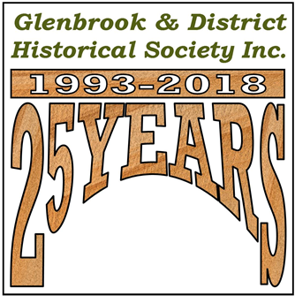

*A booklet is being produced on celebrating the 25yrs of the Society. It will include articles on how it was formed, what has been achieved, the History Walks program, the Museum and library, the Pioneers wall, Social activities, the 25th Anniversary, Afternoon teas, etc. The book will be available early 2019*

**HAMMENT FAMILY History 1846-1903**

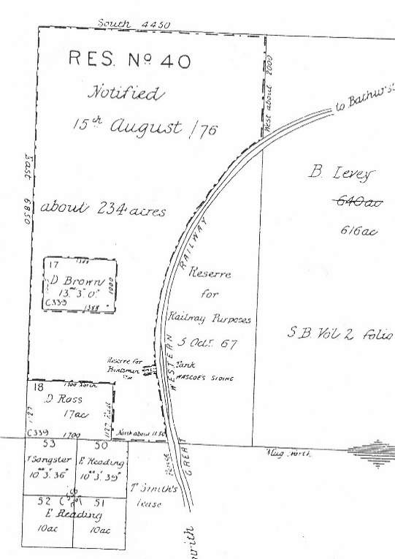 Richard & Sarah Hamment were one of the earliest settlers in Glenbrook. emigrating, as assisted emigrants, from England on the steamship “Boanerges”, arriving in Sydney on 21st Oct. 1857. They had been married 1846 in Ramsey, Huntington UK. Richard giving his occupation as a ”Farm labourer”. They had four children before migrating, viz, John 1 1848, John 2 1850, (both died under 1yr.) Emily 1854, & Elizabeth 1856. Unfortunately Elizabeth died on the journey and was buried at sea. There were 3 deaths on the journey but no official record as to the cause for each individual, just “Diarrhoea”, “Bronchitis”, “Scarlet fever”. Scarlet fever had been reported on board and the ship, with 53 crew & 475 passengers quarantined on arrival. Healthy crew & passengers were discharged on 26th Oct 1857 with instructions to “wash their clothes thoroughly”

After arriving in Sydney three more children arrived. Harriet 1859, Richard 1861, & George 1862 , Richard & George, registered at Paramatta but not Harriet. Even today she does not exist!! Their movements on arrival are not clear. We know that Richard was employed as a fettler on the Western Line c1865 and lived at Weatherboard (now Wentworth Falls) in1873 and from 1876 to 1884 they gave their address as “The Valley Western Line”, (Valley Heights). During this period the last 4 children arrived, Joseph 1865, Esther 1867, Sarah 1869, Selina 1871, their births being registered in Hartley.

Richard & Sarah, on Jan.1881, bought a parcel of land from Mr. Donald Ross who in turn had been granted 17 acres in ◄Glenbrook July 1866. The attached grant drawings were published in 1876 but refer to existing grants all of which were made before 1867. The Hamment estate, on todays map, was bounded by Ross St., Park St. and Euroka Rd. and extended South nearly to Glenbrook Creek. The coming of the railway deviation in 1913, reduced the land South, to Burfitt Pde..

**Land Grants Glenbrook before 1867 B.Levey 616acres, D.Brown 13acres, D.Ross 17acres, T.Sangster 10acres, E.Reading 3 x 10acres**

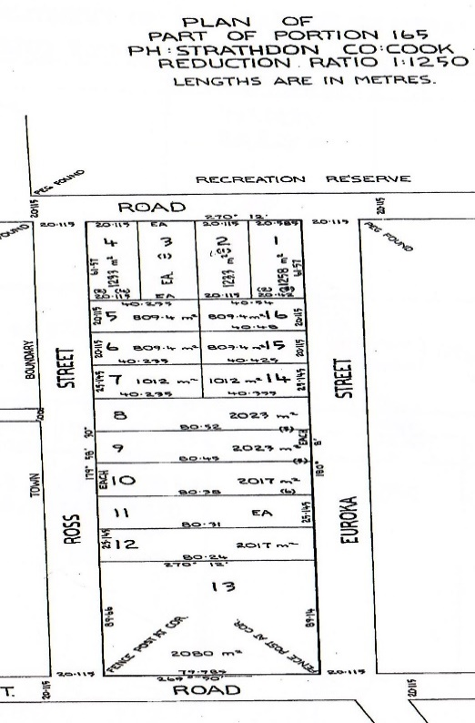 Sarah Snr. was age 41yrs with the last child and approximately one child every 2 years… what a great life!! Richard & Sarah remained there until their deaths, Richard Snr. in 1891 and Sarah Snr. in 1903. On Sarah’s death, the estate was sub-divided into ► 16 lots and published on Nov.1903. In 1904 Lots 1 & 16 were sold to William James, all original buildings were built on these lots. Richard’s life was an example to others of what could be achieved in Australia in those days, from Farm labourer, Assisted emigrant, Railway fettler to Landholder. A street was named in his honour, “Hamment St.”, unfortunately it does not exist today, being changed with the widening of the Highway. The correct postal address of Visitors Centre & Community Centre is “Hamment Place”.

**Hamment Estate Survey Map 1903**

Glenbrook (not named as such until 1885) had

become a bit of a backwater. The first road over the

mountains, Cox’s Rd., was built 1814 to open the

Western plains, not to develop the mountains. It did not

last long, The road climbed steeply over Lapstone hill,

down what is now Lucasville Rd., and then directly West

to what is now McDonalds. The climb was

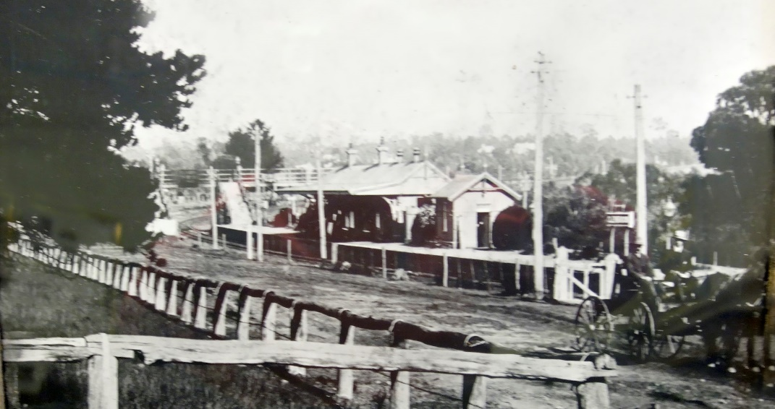that steep that often the

passengers would have to alight

and climb up the hill, horses

uncoupled and led up, the coach

pulled up by a rope and tackle

from the top, then onto Inns for a

rest. A second road known as the

Zig-Zag Rd., now Old Bathurst

Rd., was soon made 1824 and

joined Cox’s Rd at Pilgrams Inn.

This move completely stopped

any development in Glenbrook.

The construction of Lennox

bridge and Mitchells Pass from

**Hamment St. Glenbrook c1900**

Emu Plains to Pilgrams Inn 1833,

resulted in a track being built back to Glenbrook (now Glenbrook Rd.). In 1839 there were

actually two Pilgrim Inns on the same property.

Virtually nothing happened in the Glenbrook area until the railway was built 1867. From then on and until 1913 it was a railway town, Three railway lines being built from Emu Plains to Pilgrims Inn in 46 years, bringing hundreds of workers to the area. and much land development and sub-division.

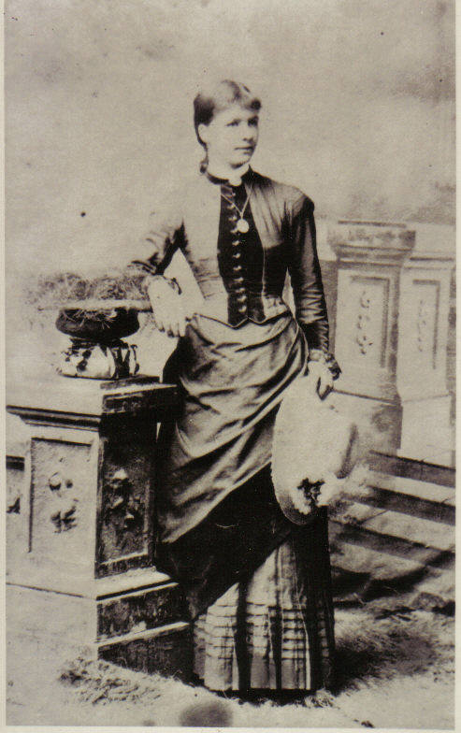 As to when Hamment’s built in Glenbrook, it is not known. Sarah Jnr. lived in Glenbrook when she married Albert Wearing April 1885. In those days, local government did not exist, people just built, or squatted in a tent. No records exist of buildings, unless a surveyor showed existing buildings on their drawings, which was not common, land was drawn vacant. The Hamment’s house is drawn at cnr Park & Euroka Rd. on a survey sub-division map 1885 of the Raymond, Mann, & Cowdery Sts area.

The Hamments were very community minded and were instrumental in the building of the 1st Public School 1892, which was built with community funds. Their children did not attend the school but their Grandchildren did. Their youngest 5 children had to travel to Mt Victoria by train 3 days per week leaving at 5a.m. returning at 6.pm, later to Springwood P.S. when this opened, being foundation pupils and then their grand-children became foundation pupils at Glenbrook P.S, in 1892. The family were the precursor to the St.Peters Anglican Church, services being conducted in their Glenbrook house, by Rev.Christie, from the Penrith area. Esther was married to John Colqhoun Dunn in the house Jan. 1887 with Rev E Creswick officiating. After the death of Richard Snr. the house became a boarding house, Glenbrook had become a tourist area on the Mountains, being advertised as such.

**Esther Hamment age 21yrs**

After sub-division of the estate the remaining children moved on. Richard Jnr.died in1905 and his wife moved away, Harriet had married and built in Levy St, Joseph married Elizabeth Dunn (sister of John Colqhoun Dunn) and moved to Lithgow, Esther and John C Dunn had built in Moore St. and Selina married to Henry Hunter Jan 1892 and built on lot 4/5 Hamment Estate. Harriet, Esther & Selina spent their entire lives in Glenbrook and 6 generations of descendants of Esther still live in Lower Mountains.

***EDITOR:****- Information for this history was from 2 main sources, 1. Family bible which had full details of Births, Marriages and Deaths of all the family. This book is in the possession of Joan Peard, great- grand daughter.*

*2. from State archives Kingswood, shipping and land title records. Photographs G.&D.H.S collection*

**KELGOOLA HOUSE (now Ilford)1884-1984**

**8 Wascoe St. Glenbrook**

CONTINUED FROM AUG-SEPT EDITION……..As previously mentioned David Brown in 1/8/1845 had been granted a parcel of land in Glenbrook for £80, a large amount in 1840’s. No street names, around this parcel, defined. There probably were none. When Donald Ross purchased this land 22/4/1884, a second Lot had been added and streets named viz.to the North… Railway Terrace, to the West …Euroka St. and to the East …Mann St. This must have caused some confusion as Euroka Rd already existed on “Hamment Estate”.

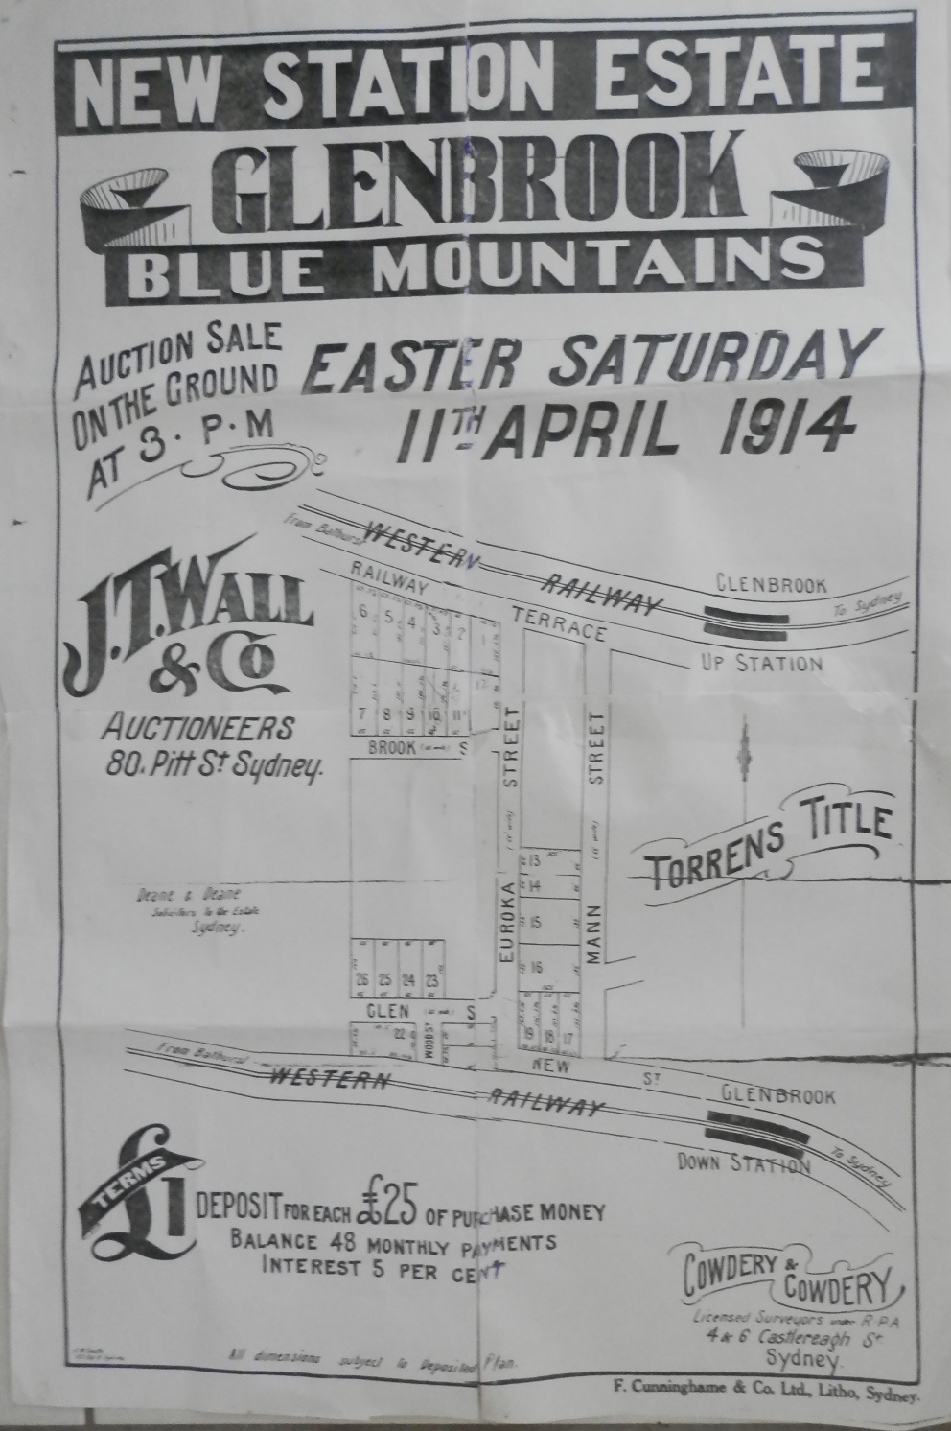 When Fredwick William Dunn of Sydney purchased the property in 3/8/1932, the streets were shown as, to the North, Railway Terrace, to the East, Mann St.to the West, Cowdery St . Cowdery & Cowdery were Surveyors in Castlereagh St. Sydney who were surveying in Glenbrook from early 1900’s. No doubt this change was made in their honour. As for Railway Terrace, the railway line had long disappeared and in 1927 replaced with the Highway. This road originally had been the way from Glenbrook station to Wascoe Station (now Blaxland), hence the name. Someone, c1933, decided that as there was no longer a railway adjacent it would be appropriate to change the name to Wascoe St.

**Railway Terrace is now Wascoe St, Euroka Rd is now Cowdrey St which now crosses the railway line, Brook St .is now Woodville Rd, Glen St. is now Deane St. New St is now Burphitt Pde.**

As mentioned earlier, after the O’Hallorans left the property and until purchased by Steven & Florence Malmberg 1984, the house was rented. Mrs Bridie Rose of Waverly bought from Irene O’Halloran 10/2/1961 and remained as an absentee owner.

Steven & Florence, formerly restaurant and motel operators and antique dealers, had migrated from Sweden 1951. Florence’s (nee Baxter) forefathers were also “immigrants” arriving in 1788 on the 1st fleet. The Malmberg’s believed that the original name was “Ilford” after finding an old sign in the house together with some school books dating back to 1867 from an English town of Ilford. Whether this supposition was correct or not remains debateable. There is little evidence of whether or not Donald Ross named the house “Ilford” but there is plenty of evidence that the name was “Kelgoola” up to 1984. The name “Ilford” remains today.

***A Tunnel Holds Much Historic Wealth***

**By Judy Prisk 1988**

Ninety years ago a young man sat on a rock in Glenbrook enthralled by the sight before him . His name was Arthur Streeton and he was 24 years old. He found the spot after following the railway line for ¾ mile or so to where “*big brown men are* *toiling all the hot day excavating and making a tunnel*”.

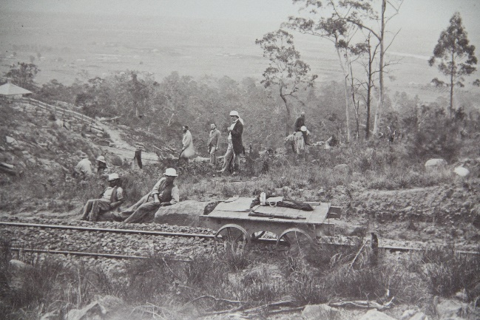 The site was Lapstone Tunnel, which was constructed in 1890-91 to bypass the slow zig-zag rail system. Writing to his friend Fredrick McCubbin, another famous Australian artist, he described the scene in miraculous detail and said “*I’ll soon begin a canvas of this,. I think it looks stunning. Tis like painting in the ‘Burning Fiery Furnace’; so beautiful and bright and yet so difficult to attain” .*

Yet he felt inadequate, “*Is it worth painting?” he wrote. “Why of course, dam it all*!. *That is provided that I am capable of translating my impression to the canvas”.* He did paint it and the result is the famous “Fires On, Lapstone Tunnel”, now hanging in the State Art Gallery.

**Men at Work Zig-Zag Lapstone**

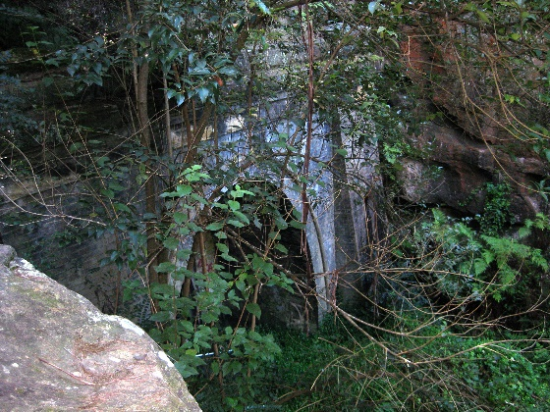 The area now looks nothing like that depicted in the painting. It is overgrown and weed infested and the 790-meter tunnel, which has been described as an engineering marvel, is now occupied by mushrooms. And as 1991 marks the 100th anniversary of the completion of the painting and the construction of the tunnel, the Lower Blue Mountains Conversation Soc. wants to clear and clean the eastern end of the tunnel, the group would love to bring the area back to its natural state so it can be part of the Eastern escarpment historic walking track. The manager of “Glenbrook Mushrooms” Tony Scott, is all for the idea. He has been fascinated by the history of the tunnel and its entrances since he began working there, and has a copy of “Fires On” in his office.

There is much to commend the site being restored for posterity, not to mention tourists. Another friend of Streeton , A.B.(Banjo) Paterson- well known as a poet but also reported to be a fighter for worker’s rights, is reported to have visited him at the site and the word BANJO with a small carving of a banjo has been found. It is recorded the only time Paterson used the name Banjo, he would wright the N backwards. The N in the engraving is back to front.

**Eastern End Lapstone Tunnel c2015**

***EDITOR:-****This is an abridged version of an article which appeared in the Penrith Press 20th December 1988. Full transcript is available at the G&DHSoc museum. Arthur Streeton was a frequent visitor to Glenbrook, staying at “Westwinds” cottage, cnr. King & Barnett Sts., still standing today. Mushrooms are no longer grown in the tunnel. Photos from G&DHSoc collection*

Pam’s Page

Mount Sion Estate….What They Said in 1926

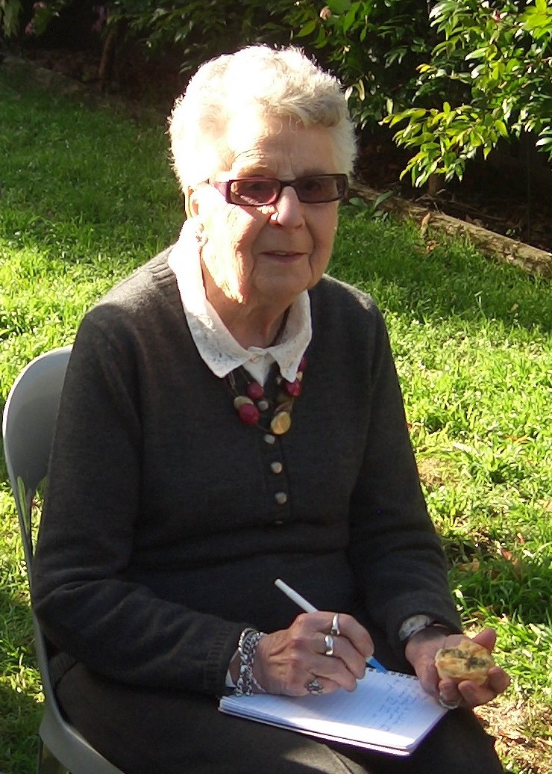

The name, “Mt Sion Estate”, was selected by the original owner, Mr Barnett Levey, who had received a grant of 640 acres land in Glenbrook c1830. He chose this name as he considered the words of the “Sweet Singer of Israel” applicable to the charming area. “*Beautiful for situation, the joy of the whole earth, is Mount* *Sion”….* Psalm 48, Verse 2

Our Blue Mountains, so well known by thousands of residents, have been called the scenic wonderland of Australia. That they are not better patronised and more thickly populated, is a matter of wonder to visitors. Only 40 to 50 miles from Sydney’s teeming population, were they situated in any other place in the world, the Mountains would be covered with gentleman’s residences of the better class. Development will surely come as Sydney’s suburbs move west.

Where can more beautiful sites for residences be found than in Glenbrook, While larger and more populous resorts have been popular, Glenbrook remains natures haven. There are numerous advantages which this estate offers to the home builder, and while previously the resorts have been a close preserve of the wealthier classes, the opening of Mount Sion marks the commencement of a new era.

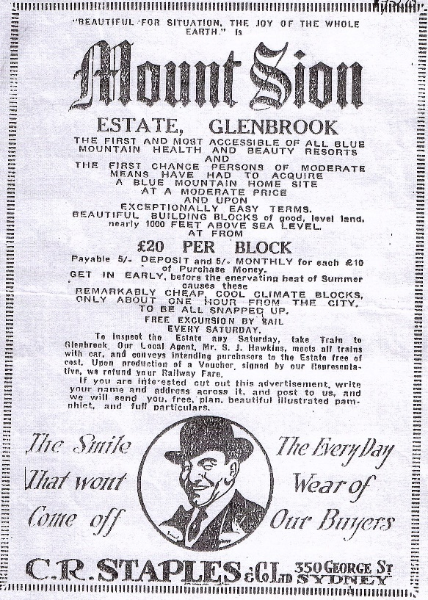 Mount Sion possesses one of the most glorious climates in summer owing to it’s altitude of nearly 1000ft. above sea level , the occasional day may be warm, but the evening heralds a drop in temperature. The views from the estate present a vista of hills and valleys, suggesting that here one is really on the roof top of the world. Another pleasing feature of the estate is that the vendor has set aside 40 acres to form a public park.

**Mt.Sion advertisment 1926**

Not the least of the attractions is the accessibility to the city, a little over an hour by either by rail or motor car. The railway service is fairly satisfactory and there are eight trains Sydney to Glenbrook weekdays from 3am to 10pm. The return service is moderately satisfactory, one can reside in Glenbrook leave home at 7.30am, be at work in Sydney by 9am. With the electrification of the railways, a complete change in passenger transportation is certain to result. Competent authorities state, that under this new development the travelling time from Glenbrook to the city would be under 40 minutes.

The town of Glenbrook has much to offer. All the usual postal facilities, also telegraph and telephone offices are available. The butcher, grocer, milkman, and other tradesmen call for and deliver orders. The School of Arts has a library and over 900 volumes, subscriptions exist for singles and families and free for returned soldiers. There is a fine hall with an excellent dancing floor for balls parties etc. There is also a good gymnasium.

The Public school has an attendance of over 60, an excellent tennis club, providing 4 courts for over 60 members and a commodious club room. Subscriptions are available for half year and yearly, and tournaments are held nearly every holiday.

**POINTS TO REMEMBER**

1. Glenbrook is the 1st and nearest to Sydney of all the Blue Mountains railway stations.
2. The Mount Sion Estate is a little over an hour by train or car to Sydney
3. The prospective high value of the land in Mount Sion is beyond doubt.
4. Unsurpassed outlook of great scenic beauty.
5. The finest climate in Australia.
6. Pure crisp and inspiring mountain air.
7. A beautiful public park of over 40 acres in the very centre of the estate.

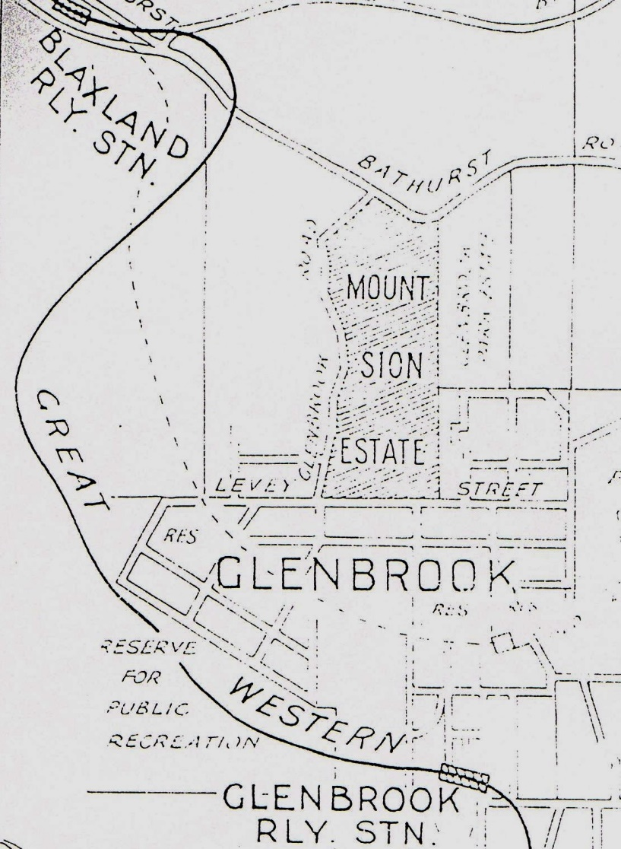 There are special weekend railway fares available, and on weekdays 1st class 4 shillings & 9 pence (50c) and 2nd class 3 shillings & 7 pence (35c) Cheap monthly excursions 1st class 6 shillings & 4 pence (65c) and 2nd class 4 shillings & 9 pence (50c).

**Portion of advertisement 1926 land sale of Mount Sion Estate by C.R.Staples & Co.**

***EDITO****R:*-*The original grant to Barnett Levey was 640 acres, (refer to page 2 this newsletter) granted c1830 and on todays map is approx., North to Mitchells Pass, East to Barnett St. South to Levey St. and West to McDonalds. This article was part of a promotional advertisement in 1926, for a portion of the original ◄grant, all the lots facing Glenbrook Rd. This section of the original grant was advertised with the dearest at £40 ($80). 15% deposit, balance 3 years. Local agent Mr. S. Hawkins resident of Glenbrook. The final section of the grant to be sold was in c1970’s and is now known as “Mt.Sion Estate”*

**Vale Betty Audry Asser**

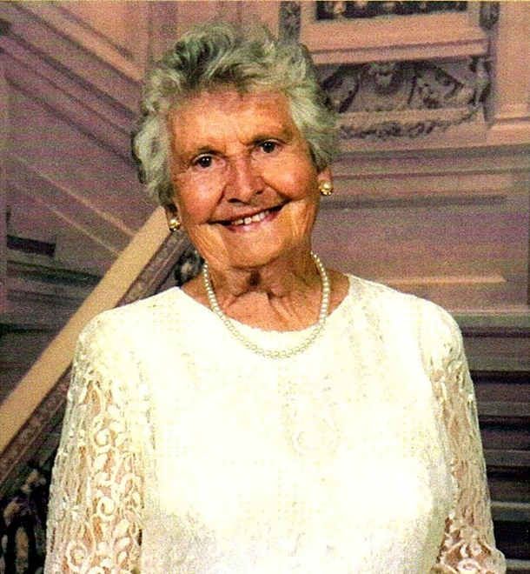Betty Asser (nee Miers) died suddenly at Nepean Hospital on Sunday 2nd September age 94. Betty was a foundation member of our Society, sister to Tim Miers, (foundation President), and Judy Berry. Betty lived in Glenbrook from the age of 10yrs, During her marriage she was away from Glenbrook for 14yrs with her R.A.A.F. husband. She is survived by 7 children, 16 grand children, 6 great-grand children, and siblings Tim & Judy. She will be greatly missed by us all.

President Joan Peard Address… 25yrs Celebration

As a foundation member of our society in 1993 I am very passionate about our Glenbrook and district history. As a society we have achieved so much over 25 years for the benefit of Glenbrook Village and district for now and the future. Just to mention a few achievements:-

1. 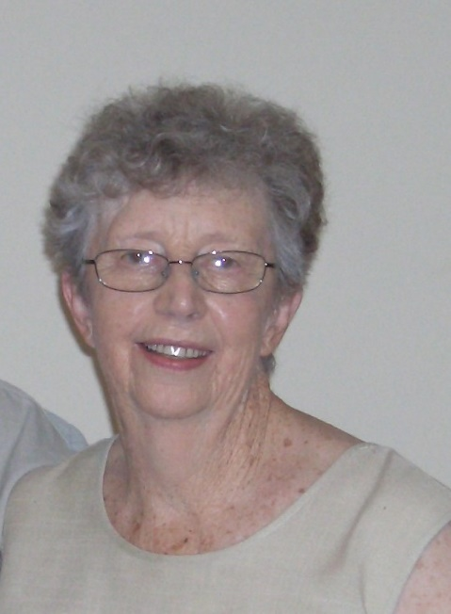Organising 125th anniversary of 1st Glenbrook Public School 1982. Lobbied against improper use of Whitton Park viz. Sporting fields. Keep beautiful park for recreation of families and friends. 2) Acquiring a building at Old Primary School at Ross St. for the use as a museum which is now fully functioning. 3) Restoring damaged plaques on historic sites, viz Lennox Bridge etc. Restoration, in conjunction with B.M.C.C., damaged “Blinky Bill” bus stop Ross St., which had been destroyed in a car accident. This bus stop had been painted by Jayne Sheppard assisted by children from school infant department, to celebrate the 100th yr. school anniversary.4) Historic walks program commenced by Tim Miers and now by Doug Knowles. These have been very successful and informative.5) Establish a “Pioneer Wall” adjacent to Visitors Information Centre to honour those early Glenbrook families. Our membership has grown from 10 to 50, and we hope to acquire a larger building for the museum in the future. Our newsletter has grown in size and readership. Being now distributed to all local Historical societies and redistributed. This is but a part of what has been achieved in 25yrs and look forward to the progress in the future as there is much more that can be achieved.

****From the Secretary’s Desk**

****The **election of offices** for next near was held on Wednesday 19th Sept. and the following were elected:- President: Denis Bainbridge, Vice-Presidents: Doug Knowles & Joan Peard, Secretary: Neil McGlashen Treasurer: Anton Von Schulenburg, Committee: Pam Thompson, Warren Page, Ian Dingwall, Librarian & Research: Bill Peard, Historian: Tim Miers, Public Officer: Kevin Frappel, Museum co-ordinator: Doug Knowles

**25th Anniversary of the Society:** 2.00pm, Saturday 1st September 2018. Joan – About 40 so far coming. On the day David Payne will talk on “Ulinbawn”, John Dikeman on “Bonnie Doone” –. Elizabeth and Pam Thompson will talk on their families and Tim about his family. Joan will talk about her family the Hamments. Doug will talk and give an official mention on the 1st Volunteer Bush Fire Brigade in Glenbrook, and Peter Berry, the history of St.Andrews church. Shirley Konza, who was secretary for many years, is coming and will assist in cutting our anniversary cake.

Did You Know??? Som***e*** Trivia

In March 1897 a young George Hamment was fishing in the lagoon only to snag in the muddy waters, a leather bag. This proved to be the property of Capt. Lee Weller who had been murdered by Frank Butler. This find was reported in all the newspaper in the Colony, front page in some. Glenbrook had become famous overnight for all the wrong reasons.

In 1950’s the owners of the Lapstone Hotel licence applied to B.M.C.C. to build a hotel on their property in Glenbrook. A section of the Glenbrook residents opposed the application and were successful. The owners lobbied to have the boundaries changed so that their property was now in Blaxland. Problem solved, no pub in Glenbrook, the New Lapstone Hotel was built in Blaxland … same site!!!

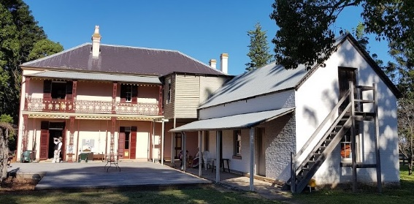From Pam Pascoe Activities Officer *I have arranged a visit to Bella Vista Historic Farm for 19th Nov. leave 9.15am Cost $10 includes morning tea & entry. The farm was part of the farming empire of MacArthur family with an historic farm complex est. 1700’s. The property was sold to the MacArthur’s in 1801. Features a two story homestead ▲ & various farm outbuildings. One of Australia’s earliest rural developments. The tour will include the inside of the homestead and outbuildings* ***R.S.V.P 12th Nov 0420 323 226 or 4739 3078 Pam Pascoe. e-mail: pplinden@gmail.com***

**GLENBROOK & DISTRICT HISTORICAL SOCIETY Inc**.

**OFFICE BEARERS 2018-2019**

**President: Denis Bainbridge**

**Vice Presidents: Doug Knowles & Joan Peard**

**Secretary: Neil McGlashen Treasurer: Anton Von Schulenburg**

**Committee: Pam Thompson Warren Page Ian Dingwall**

**Glenbrook & D.H. Society Museum is situated within the Old Glenbrook Infants School, Ross St. Entrance via Park or Ross Sts.**

**Museum is open 1st & 3rd Saturdays 9am to 1pm Entrance FREE**

