1841 English census

The 1841 census shows Richard’s family name as Hammond, not Hamment, but I am fairly sure it is the same person. The age is correct, the occupation is the same and the address is Forty foot Bridge (see notes on 1851 census below).

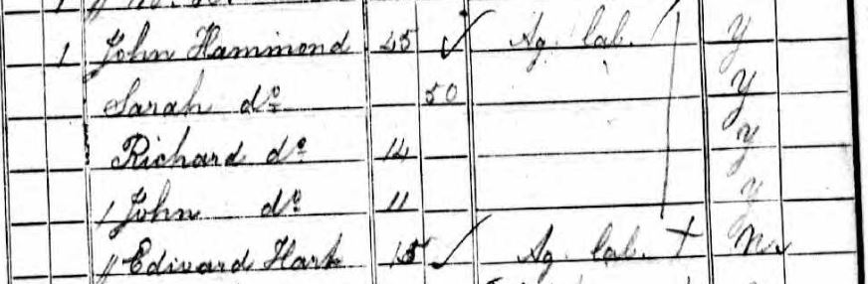

1851 English census

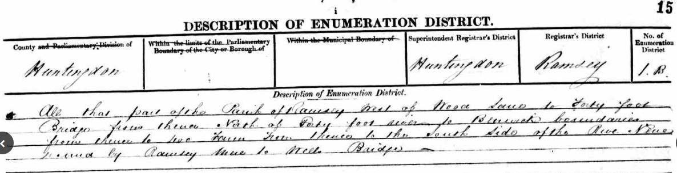

All that part of the Parish of Ramsey west of Wood Lane to Forty foot Bridge from thence north of Forty foot river to Benwick boundaries from thence to the 400 from thence to the South side of the River Nene bound by Ramsey thence to Wells Bridge –

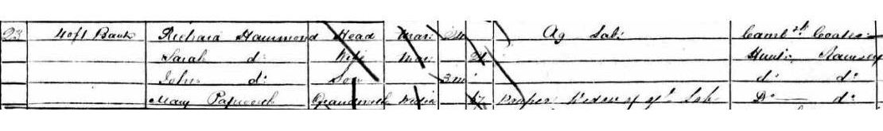

No. street name and surname rel to head cond. Age occupation where born

23 Left Bank Richard Hamment Head Mar 24 Ag Lab Cambridgeshire Coates Sarah do Wife Mar 21 Huntingdon Ramsey John do Son 3m do do Mary Papworth Grandmother Widow 67 pauper widow of Ag Lab do do

The spelling of the family name again appears to be Hammond but in 1857 the passenger list from the Boanerges clearly shows Hamment

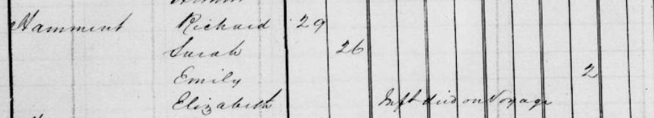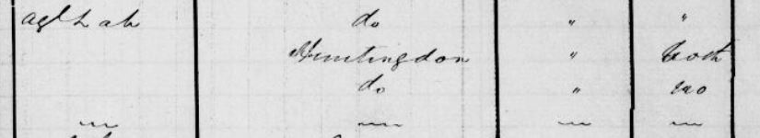

There is no mention of cause of death, only that 2 males and 3 females died on the passage as recorded by the ship’s surgeon, Edward Kearney.

As to the birth in 1859 of Harriet, I have found that the spelling of the surname was incorrectly shown as Hammant, reg no. 10810/1859 NSW BDM.