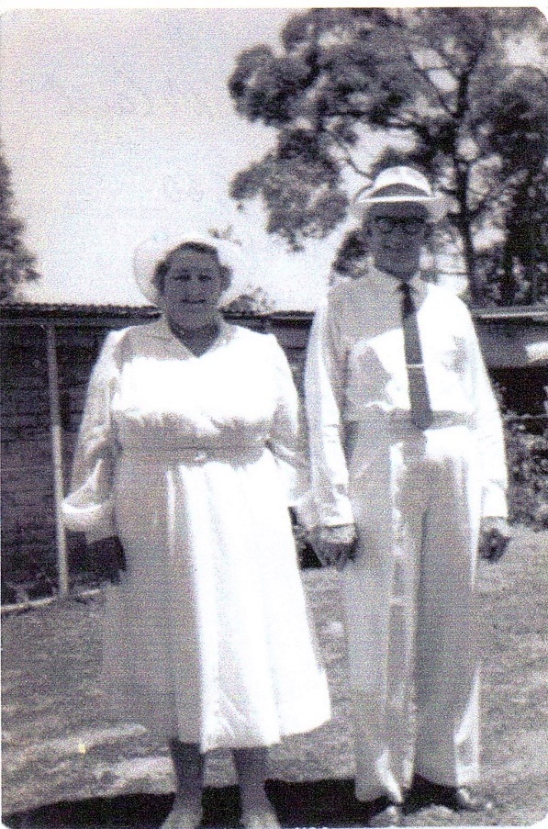**The Bakery**

**Nellie & Jim McCall & Family**

Nellie & Jim McCall started the bakery in Mann St. Glenbrook in 1946 with Bob, Jimmy & Stan, sons from Jim’s first marriage. Nellie & Jim went on to have 6 children, Kenneth, Rae, Joy, John, June, & Keith. Over the years they bought out all bakeries from Glenbrook to Bullaburra and had a fleet of delivery vans that delivered door to door.

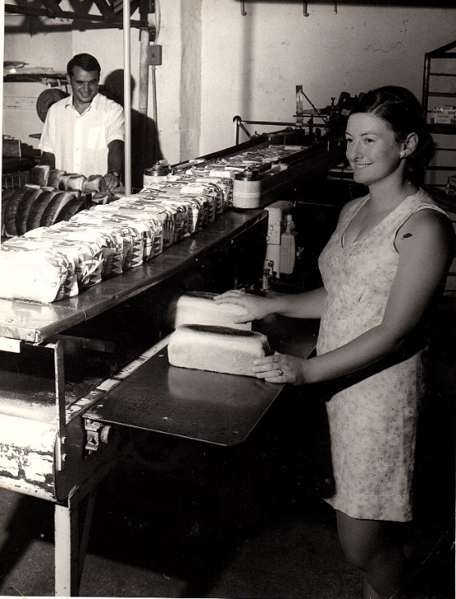 They were very involved in the village of Glenbrook, were foundation members of what is now Glenbrook Bowling Club, and Nellie was President of the womens bowls club and Jim was Treasurer for some years. Very sadly Jimmy was killed in a road accident age 21yrs whilst delivering bread. Kenneth died age 13 from a brain tumor.

**Nellie & Jim McCall**

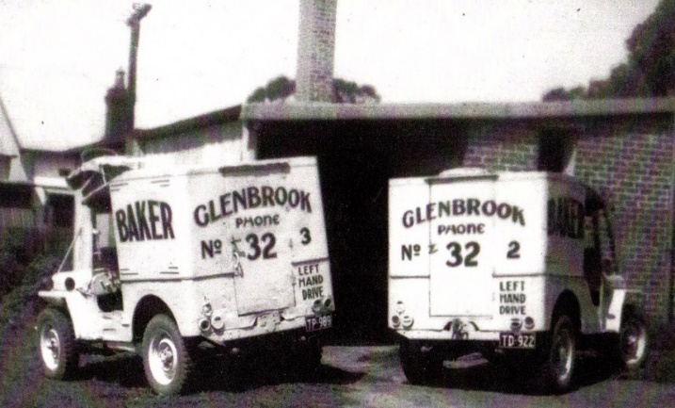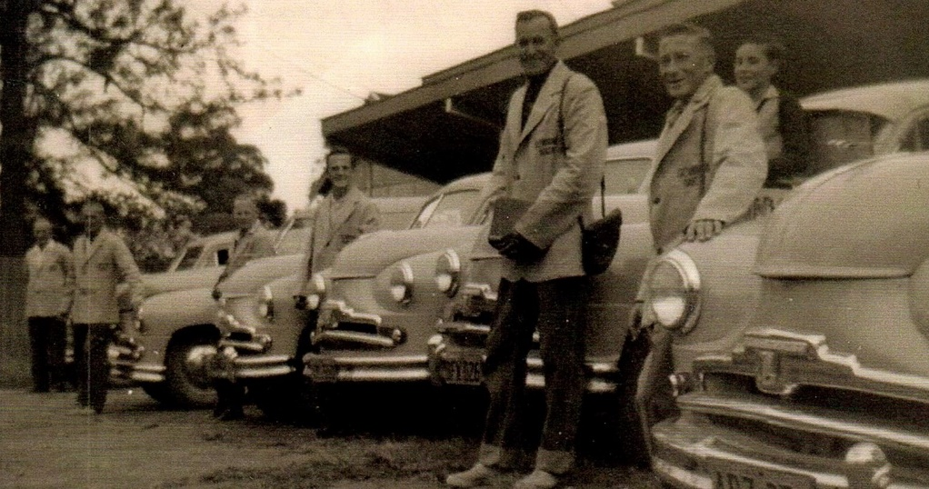 1965 Nellie & Jim moved away from Glenbrook and operated and worked in a small bakery & milk bar in Yeoval, a small country town in the West. Bob, the eldest son, operated the Glenbrook bakery with his sons. But in the early ’70’s the big bakeries had moved into the area and forced local bakeries out, so they sold out to Fielders and the Glenbrook bakery closed..

**Some of the fleet of delivery vans with bread carters**

**Rowley & Pippa McCall slicing bread**

**Rowley McCall & bread slicer "The Monster"**

**First delivery vans**

