**Glenbrook a Village**

Glenbrook is unusual in that there was no first settlers, almost everyone was just passing through. The road was built to cross the mountains, not to develop the mountains. It is believed that there were kangaroo shooters camped nearby to provide fresh meat to Sydney Town. These men were believed to have helped Blaxland, Lawson & Wentworth on the first part of their journey through the mountains in 1813. The explorers had camped in the South-East corner of what is now Glenbrook Oval.

William Cox surveyed and built the first road over the mountains in 1815. It was built all the way to Bathurst in 6 months with only 30 men. ( Road builders of today take note!), These men had a store room & camp near what is now the Glenbrook Lagoon, so they could perhaps be classed as our first settlers. In 1824 Lawson, the explorer, built a second road, known as the Zig-Zag road and today known as Old Bathurst Road. The original Cox road was far to steep on the Lapstone Hill and only lasted 9 years.

The first recorded building on the Zig-Zag road seems to have been the Pilgrim Inn at Blaxland in 1824.This stood where the Mobile Service Station is today and was a stopover for coaches on their way to Bathurst for many years to follow. Unfortunately it was destroyed by big bush fires in 1968.

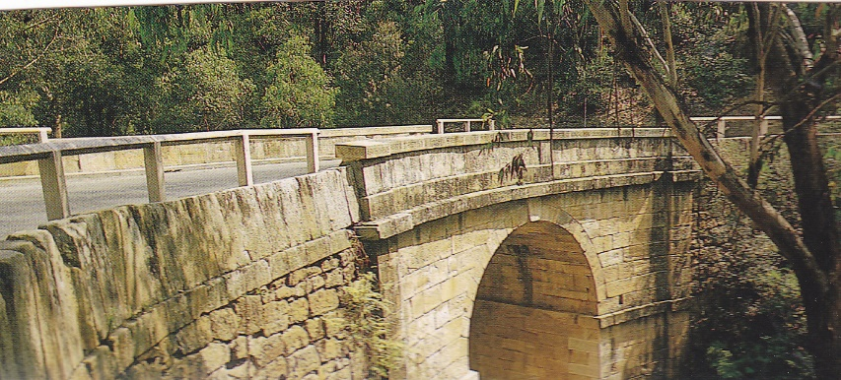 Mitchells Pass was the next and third road over the mountains, the bends on the Zig-Zag road were too sharp for the large bullock trains using this route. They had to breakup their load to get around the sharp bends. Mitchells Pass was opened in 1832 but was not named as such until it was officially opened to traffic. The road was steep and the bends were small but quite trafficable, With traffic now using Mitchells Pass this opened up Glenbrook via what is now Glenbrook Rd. Up until now our only settlers had been convicts and soldiers, but with a better road, people were starting to build holiday houses in Glenbrook. This remained the only road into Glenbrook until 19xx when the Western Highway was made over the unused railway line and then around Lapstone Hill. The Zig-Zag Rd had lasted only 8 years.

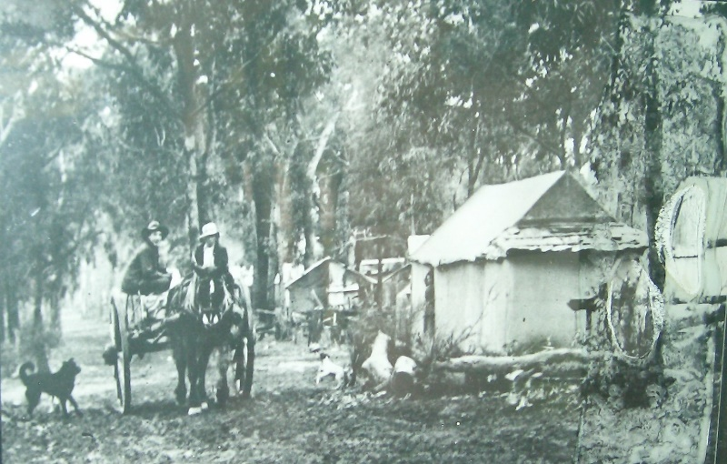 In 1865 the first zig-zag railway line was built over Lapstone Hill and then over the mountains. The railway went through Glenbrook over what is now the Great Western Highway. Glenbrook was first known as “Watertank” and with the coming of the railway came our first permanent settlers, although it was mostly a tent city, there is no record of where the first camp was. As the railway upgraded, so the camped moved to where the Mushroom Tunnel is today.

The last camp was built in 1911 at the Bluff, Emu Rd. This was a large camp and had it’s own shops and Hall. 1874 the railway renamed the station to “Wascoe Siding”. Blaxland was already called “Wascoe” named after John Wascoe, owner of the Pilgram Inn, this station was near the Inn. The name was again changed in 18xx to “Brookdale” but this did not last long as the station was renamed Glenbrook 1879.

We were declared a village in 1885 and a quote from the railway guide of 1886 “*numerous country residences have been erected, which provide a cool quiet retreat for busy city workers in the summer, Glenbrook is well laid out and the provision of wild reserves will in time make this place very attractive. The large park close to the shops will help to keep Glenbrook an attractive Village.*