A Brief History of Ulinbawn

In 1870 John Lucas purchased 10 acres of crown land at Lapstone Hill adjacent to his 1867 purchase of 45 acres. The boundary between these properties was the northern side of the abandoned Cox’s Road alignment and they were also bounded by the top road of the Lapstone Zig Zag railway as it climbed its way up the escarpment.

Lucas was a builder, contractor, innkeeper, magistrate and prominent politician. He had three modest “villas” constructed along the line of the ridge, these were named Logie, Ulinbawn and Lucasville. No doubt his interest was in speculative development of this locality which became known as Lucasville. Lucas had a subdivision of his properties drawn up in the 1880s but the blocks took a long time to sell. This subdivision created Knapsack Street.

Sir Alfred Stephen MLC requested “that a platform be erected at a spot known as Breakfast Point for special excursion trains and that tables be erected and four trees cut down”. It was opened in 1877. More likely it was intended to benefit Lucas and to serve the subdivision. A more substantial platform called Lucasville was later constructed and superseded Breakfast Point. The Zig Zag line was abandoned in 1892.

The early history of Ulinbawn is uncertain but it appears to have been built originally as a modest stone cottage in the 1870s and used by the Lucas family and/or tenanted to unknown persons. It is speculated that the name Ulinbawn indicates a likely link to the Doyle family who built a house called Ulinbawn in about 1812 at Sackville Reach naming it after their family home in County Wicklow, Ireland.

There is no description of the original 1870s appearance of the house but there are a number of clues in the current house that give reason to believe that it may have been similar in style to the residence Lucasville, except that it was built of stone.

George and Mary Yeomans acquired 3 subdivided portions of the 10 acre property from Lucas in 1883. Their house was described in 1885 as a “comfortable dwelling” and had been extended about that time to its current footprint. Railwaymen called the horseshoe curve in the line “Yeoman’s Corner”.

At the time that they purchased, the Yeomans must have considered the style of the house to be already dated. When they rebuilt and extended the house about 1884 they relocated original features such as the front door and French windows to the rear of the house and they added the large floor to ceiling sash windows to the east and north aspects.

Close neighbours of the Yeomans in the 1880s included John Lucas at Lucasville, William Lovel Davis (MLA) at Mountside, Captain Charles Smith at Logie, and Randolph Want (solicitor). There was an enclave of notable persons of the time establishing their country residences in the Lucasville locality.

The painter, Arthur Streeton, when residing in Glenbrook in 1891, painted and sketched nearby scenes, he described Mr Yeomans in a letter as "a squatter living here - by nature and religion a naturalist - is very nice to me - dined with them on Sunday - very nice people".

George Yeomans came from a family of land owners in the Walgett area, he was of the “squattocracy” and had previously worked as a station overseer. The Yeomans rented the house to the Skarratts from about 1906.

From 1918 the property was owned for a period of more than 50 years by the Skarratt family and rented out to a number of families. Past residents have included members of the Skarratt, Wall, Durham, Bennett, White, McCleave, Stobie, Hussey, Dent and other families.

During the mid 1920s, the house became the ‘Collegiate School’ and was under the stern discipline of the headmaster Mr Garnet Swift Durham. Up to about 20 pupils attended, mostly boarders who slept on the side verandah.

At times the house was used to billet RAAF personnel working at the nearby base.

The Cordin family rented briefly in 1964 and Ann said that she cried when she first moved in when she saw the state the house was in. It was barely habitable.

Following this long period of neglect, the Skarratts subdivided and sold the property in the 1960s to the O’Neill family. It was sold in 1969 to Aileen Lee and then in 1972 to the Edmonds family who substantially renovated and extended the house in 1973 to its present form adding the upstairs rooms, staircase, pool and garage. In the 1980s it was owned by the Poole and the Elliot families.

The story of Ulinbawn may be thought of as the story of three houses. Firstly, the original 1870s cottage, of which so little is known; then the more substantial residence as reconstructed and extended about 1884 for George and Mary Yeomans; and, more recently, the renovations made by the Edmonds in 1973.

Ulinbawn has survived damage from bushfires, termites and neglect and is today a comfortable home with a colourful history. The story of Ulinbawn includes numerous contradictions and mysteries that may never be resolved and will continue to intrigue.

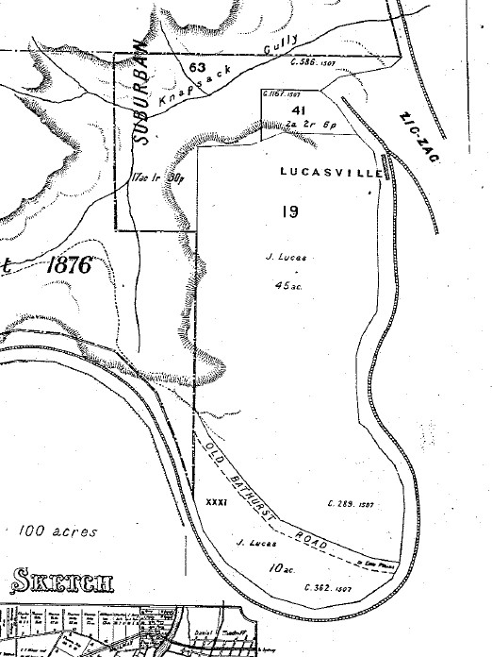
Portion of a map dated 1884. Lot 19 was purchased by Lucas in 1867 and lot 31 in 1870. The Coxs Road alignment was within lot 31.

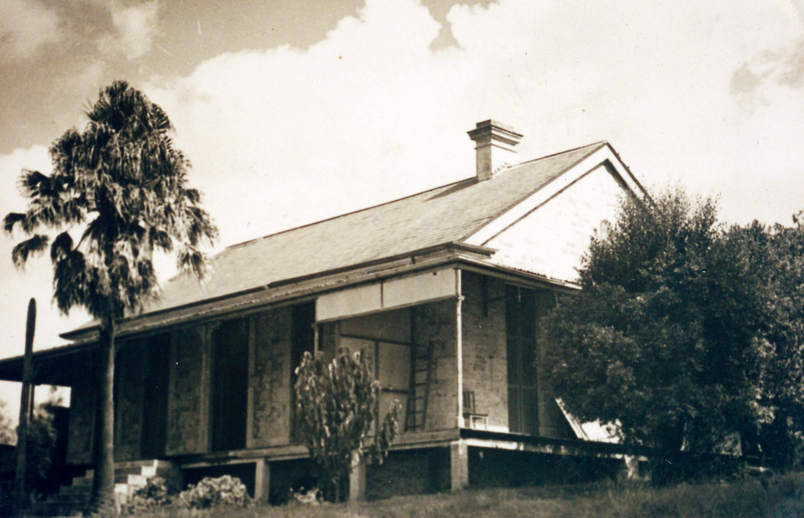
The earliest known photo of Ulinbawn, date unknown, perhaps 1950s.

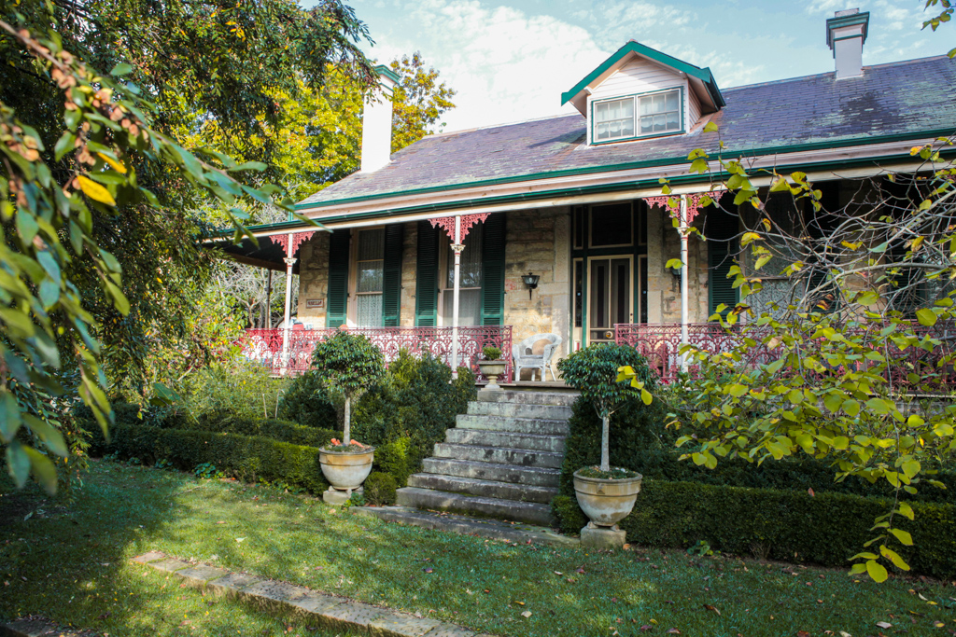

David Payne
August 2016

