**GLENBROOK POINTS**

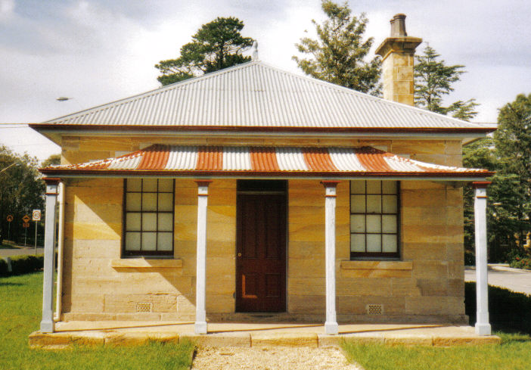**Newsletter of Glenbrook & District Historical Society Inc.**

**AUG-SEPT 2019**

**Postal address P.O. Box 38 Glenbrook NSW 2773**

**Contacts:** President: Denis Bainbridge Secretary: Neil McGlashan 4739 9864

**EDITOR** W.(Bill) Peard …. E-mail:- jpe13704@gmail.com

E-mail:- glenbrookdhs@gmail.com Facebook:- Glenbrook & District Historical Society Inc

**Meetings 3rd Wednesday monthly at 1.30 pm (except Dec-Jan)**

**Glenbrook Guides Hall cnr Hare & Moore Sts. Glenbrook**

"HISTORY WALKS" PROGRAMME for 2019.

**All on Saturdays: Walks led by Doug. Knowles & Team.**

**Aug. 10th 9.00am “Bull’s Creek.”** Railway relics:- Stone dam and steam pump relics.

**31st 1.30pm “Lapstone Construction Railway.”**  1910-1913and east portal of Lapstone Hill Tunnel 1892.**.)**

**Sept. 7th 9.00am “Glenbrook Lagoon Precinct.”** Early campsite and railway dam

construction 1880 for water supply to the first Glenbrook Station.

**28th 9.00am “Glenbrook Heritage Walk.”** Historic sites, houses and West

Portal of Lapstone Hill Tunnel--1892.**(Last Walk for the year.)**

**Adults: $10 Accompanied Children under 16yrs. Free BOOKINGS are ESSENTIAL:** Phone Doug on **4751 3275**. Please allow the phone to ring longer than usual, for details re meeting place, time and grade of walk. Good walking shoes are essential. Please bring a hat and drinking water. (No dogs please.) **BAD WEATHER ON THE DAY:** Excessive wind or rain could cause cancellation due to hazardous conditions.

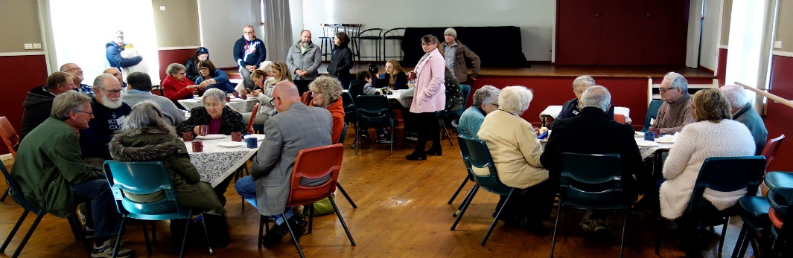***Error Pam’s Page June-July 2019****: “*The Glenbrook pioneers wall was situated at the Glenbrook Visitors Information Centre and was officially opened on 20th March 2008. This was a project of the Glenbrook & District Historical”. This was reported incorrectly as 20th May 2008, a typographical error. Editor

“”McCall” function at Baptist Church Hall Saturday 13th July ‘19

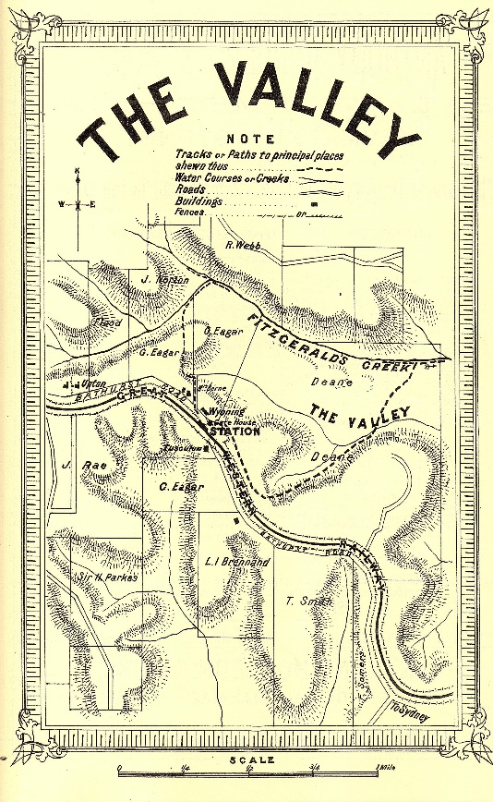Pictorial Guide

to the

Blue Mountains N.S.W.

**Published 1882 page 22**

The Valley, 46 miles from Sydney, 1048 feet above sea level. Is the name given to the prospect which opens on the view hereabouts. A lovely vale of grassed undulating land, lightly timbered and well watered, presents quite an English park like appearance.

But instead of huge gnarled oaks, beeches and elms, we have here colossal eucalypts, syncarpias and other majestic indigenous timber, while the rocks with which the gullies are faced are everywhere clothed with a wealth of ferns of immense variety.

Gleichenias, Adiantums, Dicksonias, Pteris, and a host of other forms valued by collectors may be gathered here in waggon loads. If the fortunate owner of an acre of this country could but transport its vegetation unimpaired to London or Paris, he would quickly find himself a wealthy man. Varieties , which are abound here, are frequently sold in London at from three to ten guineas ($6.30-$21) per plant

The visitor is especially advised not to leave the Valley without seeing the locality of Fitzgerald’s Creek, the upper portion of which is very rich in ferns and the indigenous flora usually associated with these mountain rivulets. By following down the Valley road for about 100 yards, taking the line of a wire fence to the left, and then turning sharply to the right over the rise, the tourist comes across some most charming scenery. The climate is remarkably mild and equable, and well suited to invalids, who may forget their ailments.

The principal residences in the neighbourhood are those of Messrs J Rae, I Brennand, W(Bill) Deane, “Upton” the property of W. Dawson, and “Wyoming the property of Mrs Berne. Good accommodation may be got at “Tuscalum” and at “Wyoming”, both near the station and as shown on attached plan. A whole day may be profitably spent in exploring the varied beauties of Fitzgerald’s Creek, its leaping cataracts and placid reaches, edged with mountain moss and ferns, as it hurries along its course to Nepean River and to the ocean.

**EDITOR:** *This is an abridged version of an article published in 1882, a tourist guide, by Gibbs, Shallard, & Co .and refers to what is now “Valley Heights*”.

*On page 20, Glenbrook got less mention than Lucasville or Emu Plains in this publication*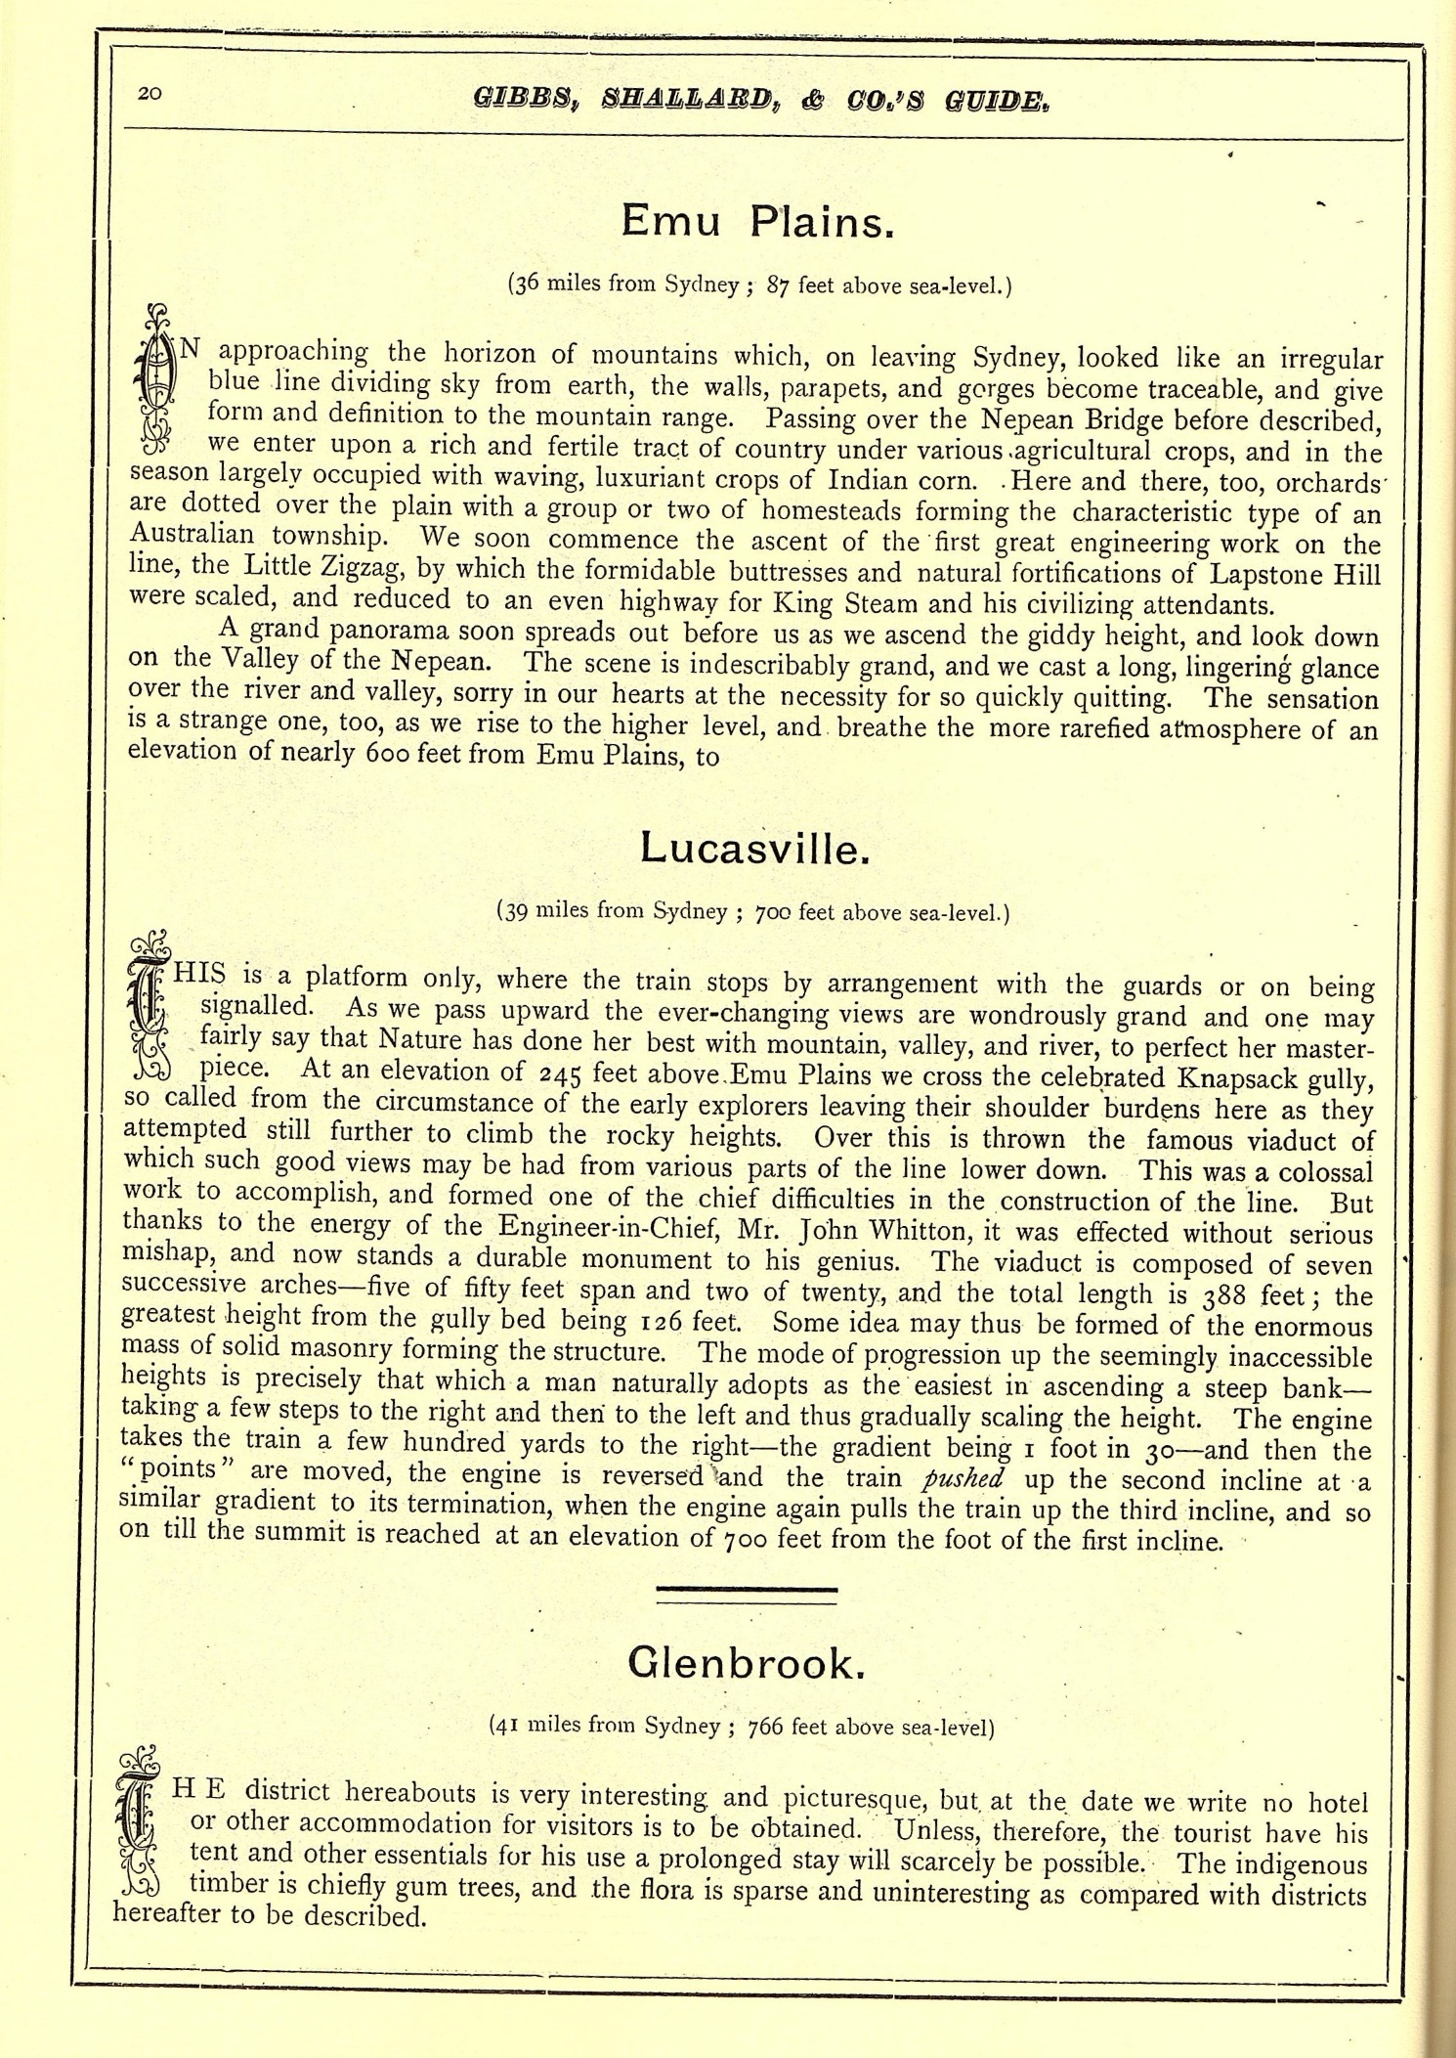

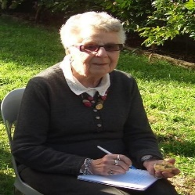

PAM’S PAGE

**Did You Know???** Som***e*** Trivia

1. Jim McCall was a foundation member of Glenbrook Bowling Club 1959 and his wife Nel, a foundation member of Glenbrook Ladies Bowling Club , 1960
2. Towards the end of WW1 a racecourse was built near Glenbrook Rd, now the area of Lennox Park. The land was owned by Mr Colin Smith and horse races were held there to raise money for returned soldiers.
3. Miss Florence Moore was appointed Post Mistress in Glenbrook in 1910, a position she held for 43 years. She handled everybody’s mail and connected all telephone calls. So much for privacy!
4. 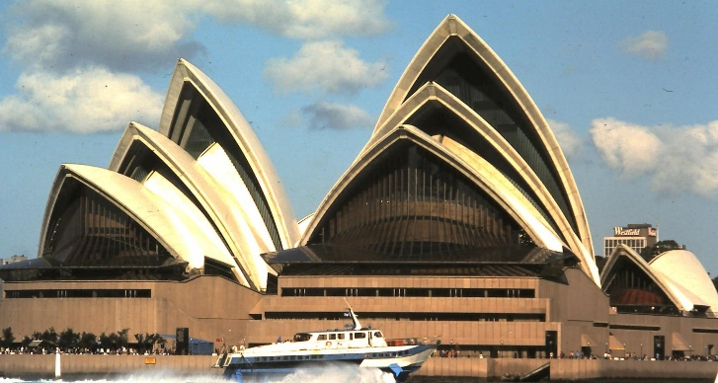What was the connection between Glenbrook & Sydney Opera House in 28th February 1966? It was on this date that Jorn Utzon, Danish architect of Sydney Opera House , dropped a bombshell of N.S.W. Government and resigned from the project. By default the Chief N.S.W. Government Architect was now in charge, Mr Edward (Ted) Herbert Farmer. Ted Farmer, as he was known, was born in Perth 1909 and by 1966 was top architect in N.S.W. with many well deserved major projects under his belt. Ted had met and married a local Glenbrook girl, Dorothy Gibbs, who lived with her family in King St. the house still stands today. They built their home and raised their family in Explorers Rd. this house still stands today, Ted died in 2001. He had declined the offer to complete the Opera House and his 2nd in charge, Peter Hall, was officially appointed as Opera House Architect, 28th March 1966. Peter, and his life, became famous in the Western World overnight. Peter was not new to publicity as he was well known through Sydney society for his love of flash and fast cars, driving to and from his North Shore home daily in one of his flash vehicles. Ted was quite different, he travelled to and from Glenbrook to work by steam train!

 ***From The Secretary’s Desk***

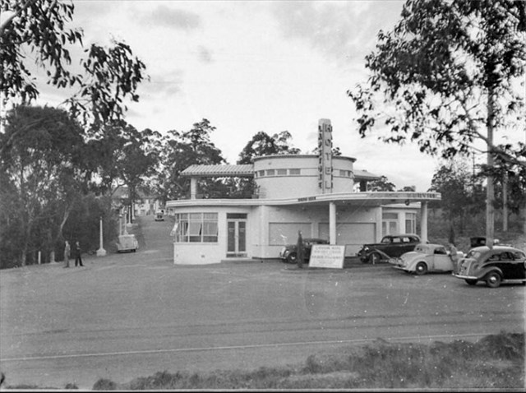**(i) Pioneers Wall Family Plaques:** Doug – the written submissions for the 17 plaques have been taken down to PC Signage to make the laser etched plaques. Proof reading was completed by Ian. In due course Kevin will help me install them when ready. **(ii) McCall Bakery Display:** Denis – it is completed and here thanks to Joan. It looks wonderful. We need to do more of these stories on story boards like this. Going up between the 2 windows on the South wall in the Museum. Unveiling on Saturday 13th July at 2.00 pm at the Museum with the Mayor then to Baptist Church Hall for an afternoon tea. and biscuits. (**iii) Tricia Murnane**– gave a fine report to the meeting on her attendance at the book launch by the Blue Mountains Education and Research Trust on 5th May. The book is 'Aboriginal Heritage of the Blue Mountains' and edited by Kelvin Knox and Eugene Stockton. Tricia kindly provided a copy of her report via email which was sent out to members with email**.(iv) Road House:** Tricia – the Road House on the RAAF base is being renovated. Pam T. – first of its type in Australia. RAAF changed it inside to a communication centre. **(v) Book Launch**- Past Pres Doug attended a book launch at Lapstone Hotel on Monday 24th June, “The Duck Hole” authors MIchael Keats AOM & John Fox. The book was mainly a history of the water resources at Duck Hole and its use by steam trains at Glenbrook. The book was very comprehensive with many interesting old photographs. Part of their concluding statements, No 6 pge 68, “*Water from Duck Hole was pumped direct to water tanks at the former Glenbrook Station”.* This debunked the theory that water was pumped from Duck Hole to Lagoon. The book is available at G&DHSoc. museum for $30 or may be read at the library **HISTORIC SNAPSHOT** ~ Roadside Bar that opened at Easter in 1940. The Roadside Bar was claimed to be the first of its kind in Australia.

.

**GLENBROOK & DISTRICT HISTORICAL Soc. Inc**.

**OFFICE BEARERS 2018-2019 President: Denis Bainbridge**

**Vice Pres: Doug Knowles & Joan Peard**

**Secretary: Neil McGlashen Treasurer: Anton Von Schulenburg**

**Committee: Pam Thompson Warren Page Ian Dingwall**

**Glenbrook & D.H. Society Museum is situated within the Old Glenbrook Infants School, Ross St. Entrance via Park or Ross Sts.**

**Museum is open 1st & 3rd Saturdays, 9am to 1pm, Entrance Free**

APPLICATION for MEMBERSHIP of ASSOCIATION

*(Clause 3 (1)*

**GLENBROOK** & **DISTRICT HISTORICAL SOCIETY Inc.**

*(Incorporated under the Associations Incorporation Act, 2009.)*

***P.N: Would you please use a black pen and write firmly.***

I: ............................................................

[Full name of applicant:

**of:** ............................................................................................................

**[Address]**

**Phone:.....................** **Email: ...................................Occupation..............................**

# hereby apply to become a member of the above named Incorporated Association. In the event of my admission as a member, I agree to be bound by the Constitution of this Association.

**Signature of Applicant: ....................................Date: ..................**

Please enter your choice of annual fee from the separate price list.

$**.............** **plus joining fee: $5.00** = **Total** $**...............**

I give permission for my telephone number and email details to go on a list for members only use. Please tick if you agree

For insurance purposes, please indicate age category: [18 - 50yrs ..…] [51 - 70yrs .....] [71 – 85yrs..…] [86yrs + .....]

Please send this completed Application Form to:

Secretary

Glenbrook & District Historical Society Inc

**PO Box 38 Ph: 0420 660 388**

**GLENBROOK NSW 2773 Email:** [***glenbrookdhs@gmail.com***](mailto:glenbrookdhs@gmail.com)

Or: Bring with you to the next meeting: Every third Wednesday of the Month, (except December & January,) at 1.30pm at the Guide Hall, Cnr. Moore & Hare Streets.

*We look forward to seeing you at our next meeting or event:*

*From the Management Committee.*

***3/19.***