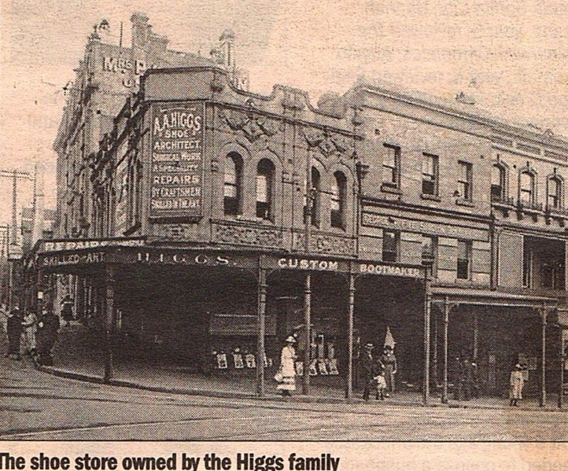Valley heights murder mystery 1927

Around 1900 Albert Higgs had a shoe store in Kings Cross Sydney, he and his family , 3 sons, Hubert, William (Bill) & Bruce, lived in Rose Bay Why then did the three Higgs brothers become suspects in what became known as the “Mountain Murder”

It would later be alleged that on the 12th October 1927 the three brothers hired a dark blue Buick sedan and travelled towards the Blue Mountains.

12th October 1927 Mr Ronald Leslie left his home in Manly early in the morning. He was to drive to his property in Parkes in his dark blue Buick sedan via the Western Highway

About 10 a.m. , Mrs Fessy was tethering her cow in Valley Heights, when she saw a car come through the railway underpass with two men in the car. She heard what she thought was a car backfiring 3 times and then saw one man helping the other into the back seat. Finally the car came back through the underpass with only one person in it. 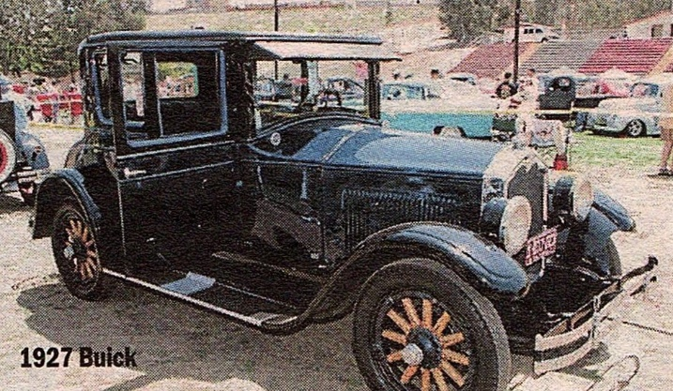

The following morning she heard a radio report of a murder on the mountains and contacted the Penrith Police. What she had heard was probably 3 gunshots and not a car backfire.