At our June meeting Kate Matthew will be our guest speaker. Kate is an historian researching the “Old Lapstone Hotel”
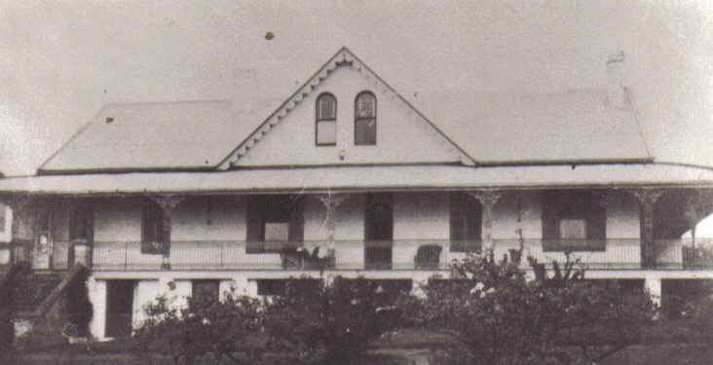
“LOGIE” c1920
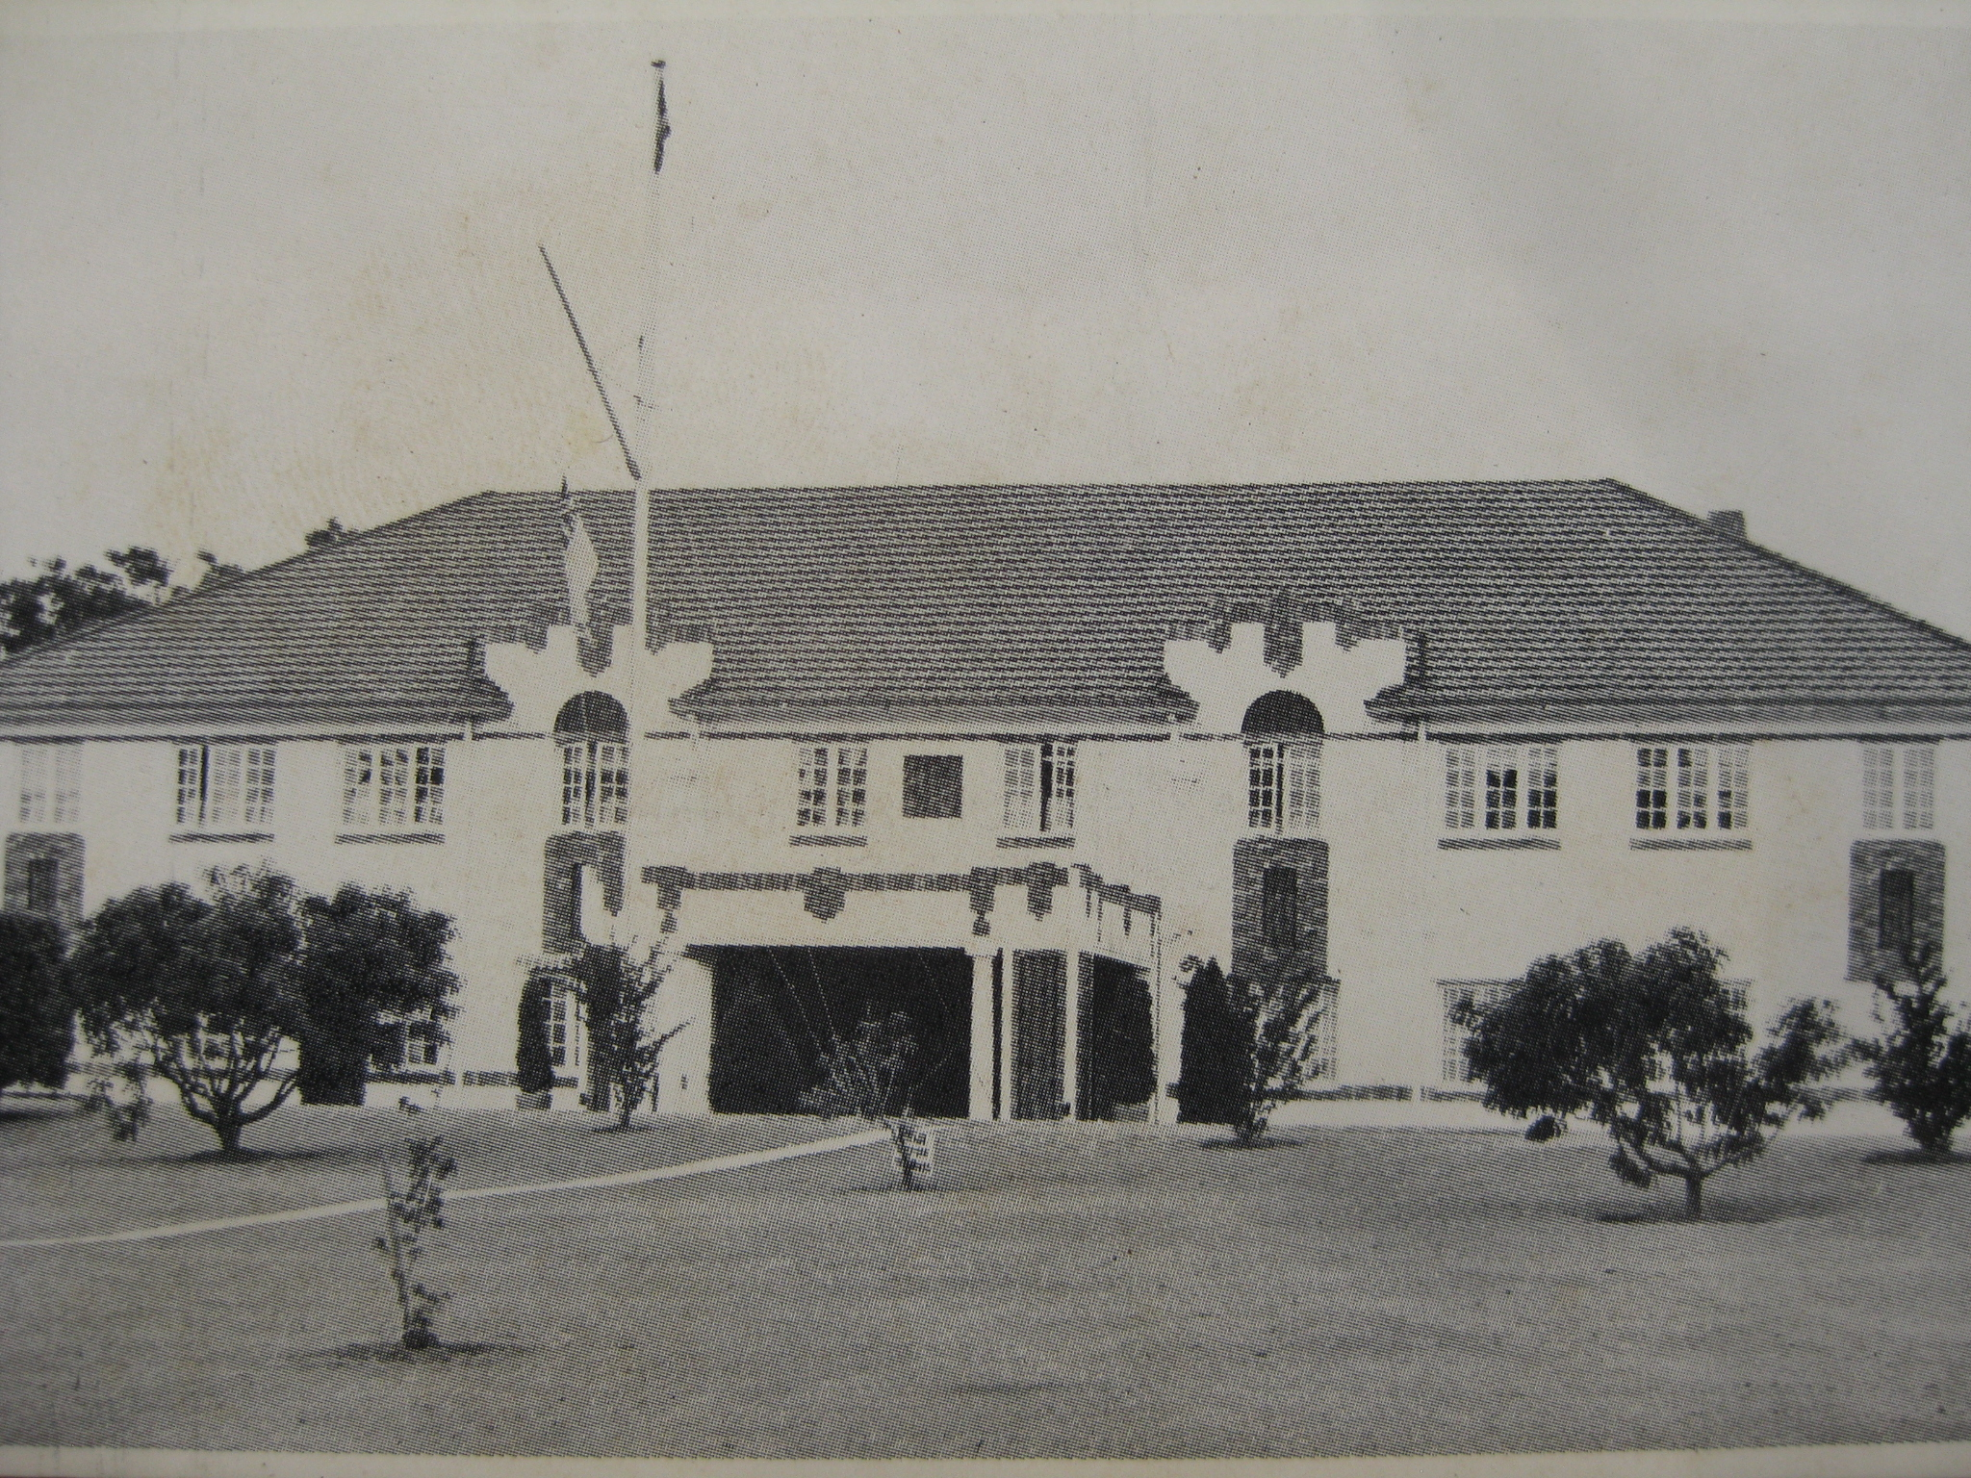
LAPSTONE HOTEL 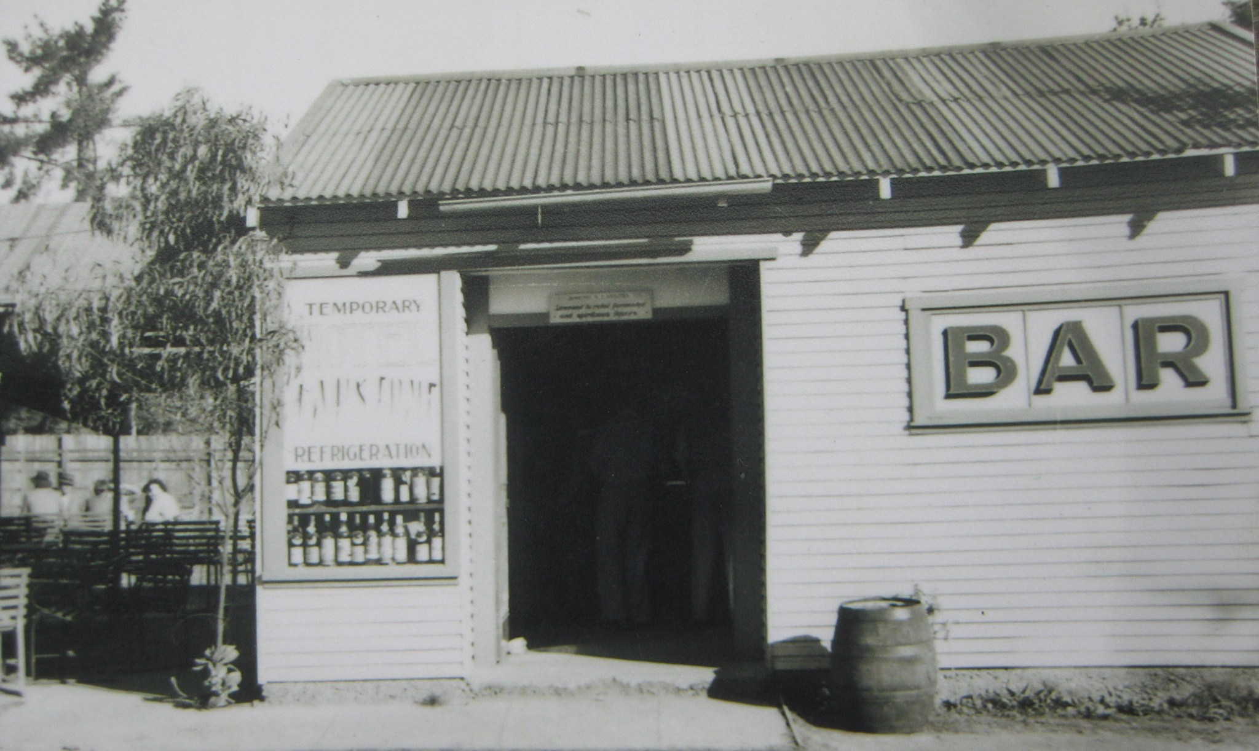
HOTEL ROAD BAR c1950
Three stages in the “Lapstone Hotel”. First the “Logie” residence was sold & converted to the “Lapstone Hotel” then Hotel sold to R.A.A.F. who sold the licence to Joe Langtry who reopened in temporary premises on highway Glenbrook. This bar was situated on a small parcel of land west of garage. Bar was at the front & beer garden at rear facing Wascoe St. The bar closed & “New Lapstone Hotel” licence was moved to present site. Recently the name changed back to “Lapstone Hotel”

