SCHOOL DAYS GLENBROOK 1881 -1892
Way back in the 1880‘s in the little village of Glenbrook there were problems with public education for the few children atttending school. In those days children were issued with a PASS to attend a public school which was issued by Dept. of Instruction in Sydney. In 1881 the residential population of Glenbrook was about 50-60 and 12 children travelled by train to Springwood. Probably some public servant in Sydney looked on a map and discovered that Emu Plains was closer to Glenbrook than Springwood and thus PASSES would now be issued for the children to attend Emu Plains Public School. What a commotion this started in the small village.
Mr Miles, a local resident, writes to < Secretary Dept. of Public Instruction October 1881......Sir.. I beg to lay before you the following statement on behalf of myself and neighbours, we have some 11 or 12 children at Glenbrook who have been in the habit of attending the Public School at Springwood ever since it has been opened until this last month, since it has been decided that Emu Plains Public School is nearer to Glenbrook, we cannot now send our children to Springwood as we cannot get passes for them ,only to Emu Plains, and I beg to show you the difficulties we are under in this respect. 8 out of the children are girls under the age of 10yrs and in sending them to Emu Plains School they can only be conveyed by trian to Emu Plains Station, they then have to walk 1 ½ mile (2.5K) to the school from the station. The school is only as the crow flies, nearest to Glenbrook, and I do not think the Act was ever intended to put such difficulties as this in the way of children attending Public Schools. When going to Springwood School, they were taken taken up close to their home and set down close to the school and brought back the same way in good time and without any delay to the trains........... we hope Sir that you will be kind enough to get this altered for our children‘s sake...... We are Sir yours respectly W.Miles >
Mr W Miles was not the only one to write, he was supported by the Principal of the Springwood Public School who penned a letter to the Dept. on Oct 1st 1881 < Parents of pupils residing at Glenbrook & Blaxland have requested me to place before you the great inconvenience and hardship their children will have to endure, if they are compelled to attend School at Emu Plains
I have no doubt that if all the facts are properly placed before you, their case will receive your favourable consideration, and to advance their interests I enclose letters which the parents concerned have sent to me.
I am personally interested in your recent decision about the issue of passes, in asmuch as it will considerably reduce the attendance of pupils at the school under my charge and consequently lower our numbers as these children mainly support the school, for the population of Springwood is not large enough to support one without them.
Considering the question of convenience, I may also inform you that I have been of some service to the Railways Dept. having for the last three years personally supervised the arrival and departure of these children, so that there should be no delay or trouble to the Officers of your Dept. and considering the additional labour this has involved, though not my duty, this fact alone ought to induce you to remove this obstacle in the way of children attending school at Springwood. The more so, as it is the School they have attended, and still desire to attend.....I have the honour to be your most obedient servent, Mr Showe Principal >
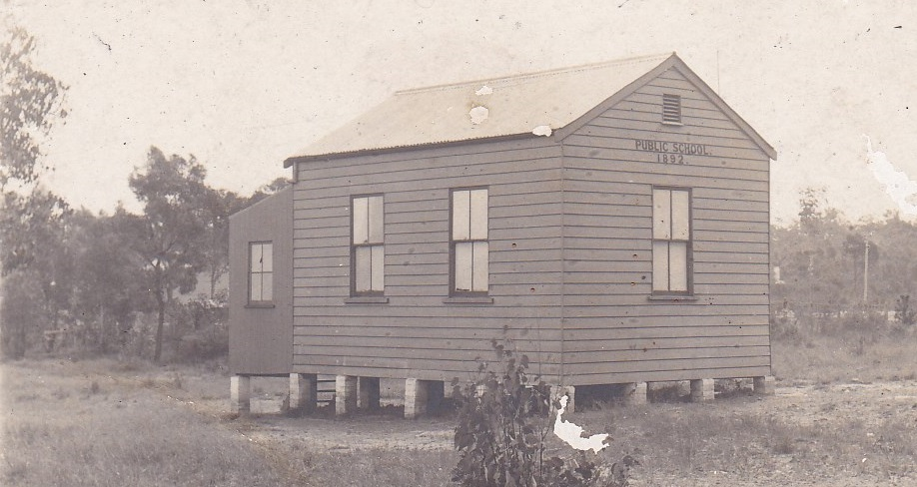
It appears that the residents must have succeded as children from Glenbrook & Blaxlend attended at Springwood until the new school opened at Glenbrook on May 9th. 1892. This saved them from leaving home about 7 am and then not returning till about 5 pm It is also interesting to note that Springwood in 1881 could not support a school. Attending the closest school was in place for the next 100yrs, now replaced , with the advent of modern transport, by attendance of your choice. Pge 3:-
1st GLENBROOK PUBLIC SCHOOL 1892
Near GREEN ST. in park

FROM page 2
Opening of the new school, which was built in the NE corner of Glenbrook park, was not without it‘s problems either, a very young Miss Sylvia Hall of 21yrs was sent to Glenbrook as a teacher to commence the school. Sylvia had started her career as a probationary pupil teacher, age 14 yrs, at Redfern Infants School on May 30th 1886 and promoted to a pupil teacher on Oct 16th 1886. She was transfered to Paddington Girls Public School on Jan 6th 1887, then had a short appointment at Glenmore Road Infants from Sept to Oct 1891 before being asked to act as a sole teacher at Glenbrook on April 28th 1892. Sylvia stayed at Glenbrook until Dec 1893 being transfered to Mt Victoria. Her last appointment was at Thirlmere 1904 and retired 1906. It is not recorded whether she married or not, she reired age 38yrs.
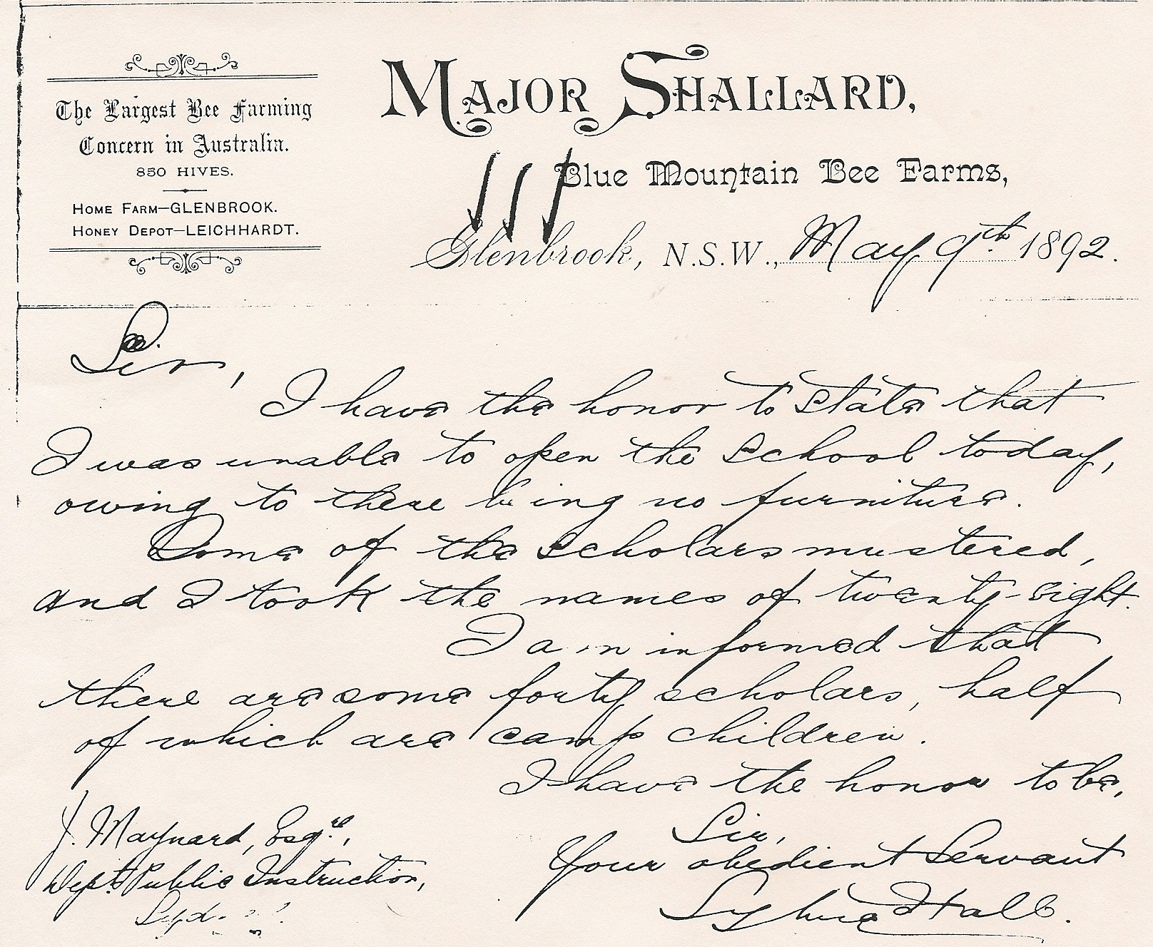
It must have been a great culture shock from commencing her career in the inner city for 7 years then arrive at Glenbrook, age 21yrs. , population about 100, and sole teacher. Her problems started on her first day, the school had no furniture!!!!!! Probably had no paper either as she writes a letter to Dept of Public Instruction on borrowed letterhead as follows:-
Glenbrook May 9th 1892.... Sirs, I have
the honor to state that I was unable to open the school today, owing there being no furnitures. Some of the scholars mustard, and I took the names of twenty-eight. I am informed that there are some forty scholars, half of which are camp children. Your obedient servant ….Sylvia Hall

Major Shallard (Major was his christian name ) also wrote to the Dept. on May 23rd 1892:-< I beg to inform you that even with the new seats..not half the children have sitting accommodation. There are nearly 60 children attending & they require at least 5 more seats. They also require an assistant as one teacher cannot possibly pay proper attention to so many. Also the want of closer accomodation, there are no neighbours near the school, it must be very inconvenient for the teacher.>
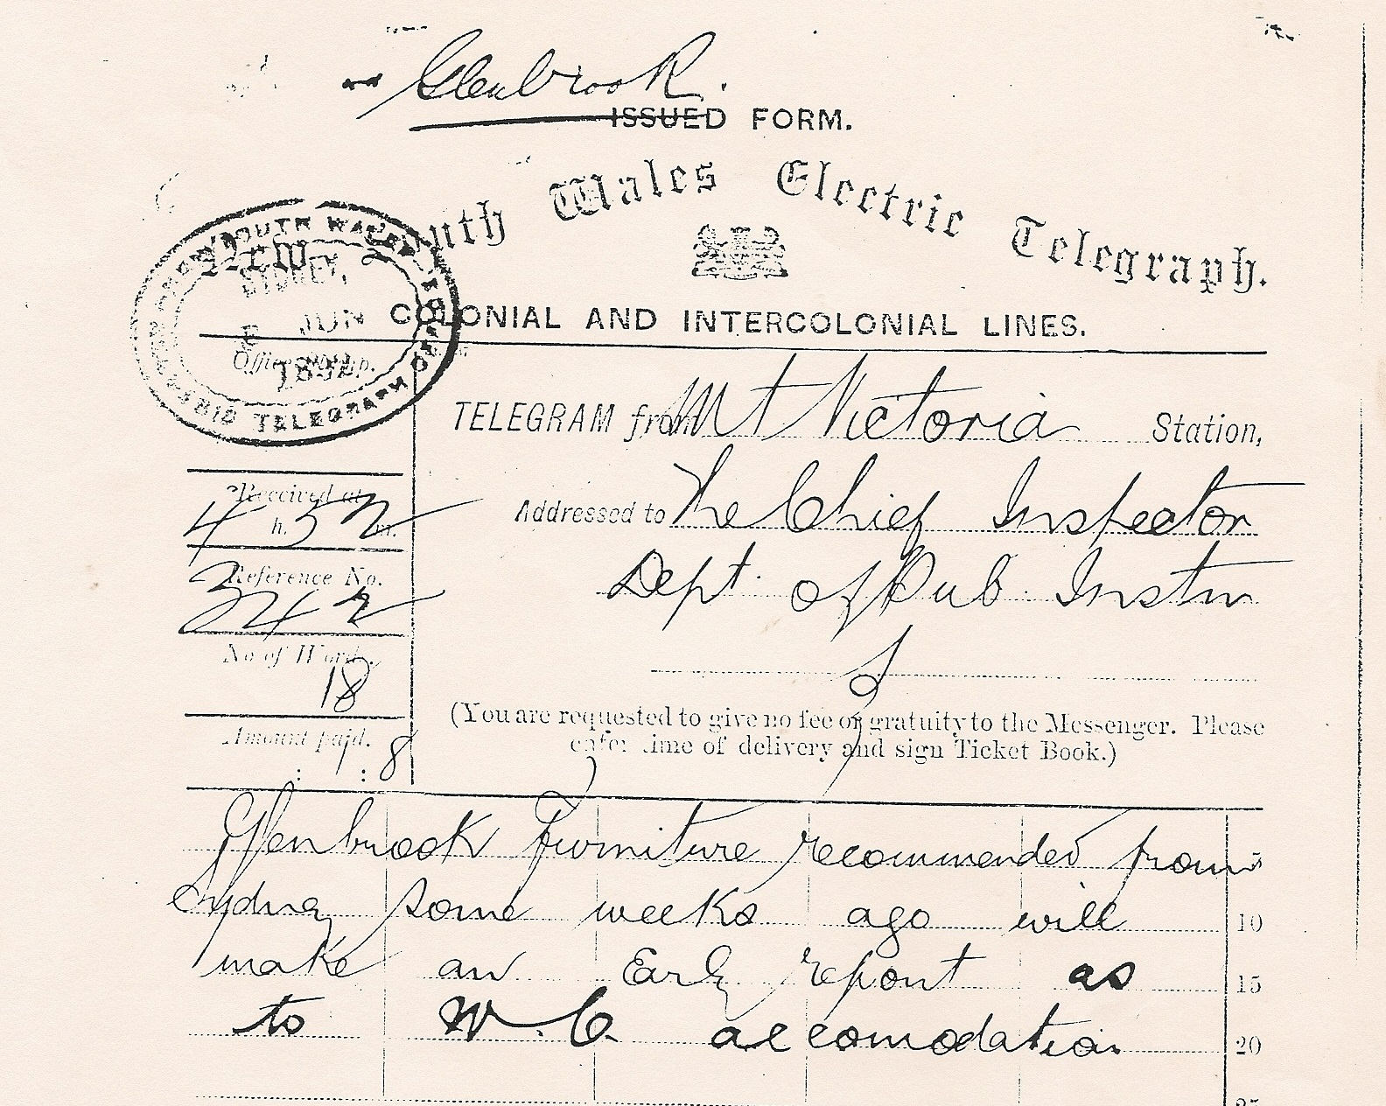
Major Shallard must have been a resident of some importance, claiming to have the largest Bee Farm in Australia, with 850 hives in Glenbrook and a depot in Leichhardt. He operated from a parcel of land between Belata St. & Explorers Rd. He must have had some influence as on 8th June 1892 a telegram from the Inspector of schools reads:-< Glenbrook furniture recommended frcm Sydney some weeks ago will make an early report... as to accommodation > …. 4 more forms were sent. Telegrams in 1892 were sent through railway‘s system , a common practice in small locations.
The school population had rapidly increased due to the influx of railway workers and their families, they are the camp children in Sylvia‘s letter. These large camps remained in Glenbrook & Blaxland until the completion of the deviation & duplication of railway.

FROM THE SECRETARY‘S DESK
Australia Day in the Park: We had a good day in the shade as usual, and banked $380. Even though it rained a little, we had a lot of visitors and some of them wanted to talk. We gave out lots of 'History Walk' programmes. Some asked questions and they seemed happy with our answers. We also learned some things from them. I would say it was a successful day.
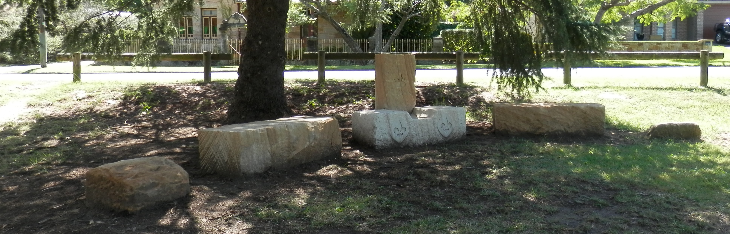
Contacted Nell Aston, she answered the phone, was very frail-sounding, and had the handset taken from her by a man (possibly her son,) who was very rude, I hung up. She is still, however, a Life Member .
Blocks of sawn Gosford stone, have appeared in Whitton Park. Does anyone know anything about it? No one does. But Pam will enlighten all at next meeting.
At the April general meeting, our guest speaker will be Marcia Cooper, whose Grandfather, Thomas Edward WHITTON‘s PARK STONEHEDGE
Gratton-Smith lived in Glenbrook from 1910 for many years. He was a children's author and an artist and did radio work as a reviewer of books.
The Mayor phoned to give an update on the Bus Shelter. The local Chamber of Commerce have
disagreed with the way we want it painted. The Mayor will put a resolution to Council to say that it
will be painted the way we want . He is sure that he has the numbers.
Neil & Jennifer have a list of books that are available for loan from the Library in the Museum. Tim thanked Jennifer for putting all of our books on computer. We now have some control over them that we didn't have before.
Lyn Collins came to the Museum on 25th February, to have a look around. He said that we have
made good progress with it. He said it would be a good idea to spend some money and digitise all our
records...... EDITORS NOTE:- Many of our records are now digitalised, documents , photographs,
and Newsletters from Feb-Mar 2012 are accessible from the Society's computer. Also 500 + photos
in the system, but unfortunately many have no captions (although most are available) and there is
little or no catalouging or indexing... except for NEWSLETTER. To make the computer workable,
records need to be indexed, catalouged & easily accesable. A computer work station would be a good
investment, as at the moment is computer not readily available, being kept unassembled in a locked cabinet.

